Electrolux Major Appliances – Europe

Web EDI

Electrolux Major Appliances - Europe
Web EDI team

1. Version control 3
2. Electrolux WebEDI based on Odette e-Forms 2 5
3. The first login 7
4. Change the user password 12
5. Change E-Mail notification 14
6. Sub-user administration 15
7. Electrolux WebEDI 18
8. Display, print and download delivery instruction: (STDP short term delivery plan) 20
8.1 Mass print delivery instruction 20
8.2 Display and print the production plan 22
8.3 Download of message 25
8.3.1 Example Excel-download 25
9. Call-Off Process 27
9.1 Introduction 27
9.2 Working with CALL OFF 27
10. Purchase ORDERS 28
10.1 Print ORDER message 28
10.2 Download of message 29
10.2.1 Example Excel-download 29
11. Delivery and transport data 32
11.1 Shipments 32
11.2 Packaging information 41
11.3 Labels 55
11.4 Example 1. First shipment with the completion of the packaging master data 57
11.4.1 Information about the packaging 57
11.4.2 Start with shipment 57
11.4.3 Update packaging master data 58
12. Invoice 65
12.1 Start with invoice Error! Bookmark not defined.
13. File exchange option 76

Version control

Version | Date: | Changes: | Responsible:
 | 2009-05-12 | Additional information and definition | Peter Noonan
10 | 2009-05-21 | Chapter 11, explaining managing delivery and transport data was significantly edited and expanded | Pavel Novikov
11 | 2009-06-03 | Update of 11.1.1.5 Shipping data Tab  Chapter 12, Invoice, has been expanded.  Shipping numbering information updated Small update 11.1.1.2  Information about content of production plan has been edited in 7.2 | Peter Noonan  Pavel Novikov, Dominik Kurpiel
12 | 2010-10-18 | Update of Chapter 8  Chapter 12, small changes | Dominik Kurpiel
13 | 2011-06 | Update of Chapter 11, additional information how tab “supplier” must be completed | Malgorzata Wojcik
14 | 2011-11-14 | Update of Chapter 9 information about Purchase Orders | Malgorzata Wojcik
15 | 2013-08-07 | Updated of  Chapter 3 - The first login, add new screens - Welcome page has been updated, Description of Returnable packaging has been added  Chapter 4 - chances under "Personal properties" and Sub-user  Chapter 7.3 - Download of message, downloaded messages automatically moved to excel  Chapter 9.3 - Download of message, downloaded messages automatically moved to excel  Chapter 11.1.1.4 Transport units tab - returnable packaging added  Chapter 12 - Invoice - new functionality in WebEDI invoice in foreign currency | Malgorzata Wojcik
16 | 2014-02-10 | Updated of Chapter 13 – Documentations about uploading function | Malgorzata Wojcik
17 | 2018-01-30 | Chapter 12 – Revision and update  Chapter 13 – Update, New examples | Marcin Szeliga  Malgorzata Wojcik
18 | 2018-04-20 | Revision and Update  Chapter 11 - Delivery and transport data  11.1.1.5 Shipping data tab  Chapter 12 - Invoice  12.2 Invoice based on Toyota Delivery Docket – Plant (Supplier) | Martino Gottardi  Claudio Venturini

Electrolux WebEDI based on Odette e-Forms 2
Electrolux Major Appliances Europe (EMA-E) has the target to connect all of their factories to all of their “Direct Material Suppliers” by either traditional EDI, or by the internet using WebEDI (in the case of those Suppliers that cannot support traditional EDI)
This document explains how the Supplier can work with the new internet based Web EDI tool
The following business processes will be managed:
Delivery Instructions (STDP short term delivery plan) – The STDP is sent to the supplier at least once per week (Some “Delivery instructions” will be sent the Supplier on a daily basis). The STDP is sent with daily resolution for data of first 4 weeks and weekly resolution or data from week 5 onwards and contains the net demand per ANC to be delivered to Electrolux at a certain day.
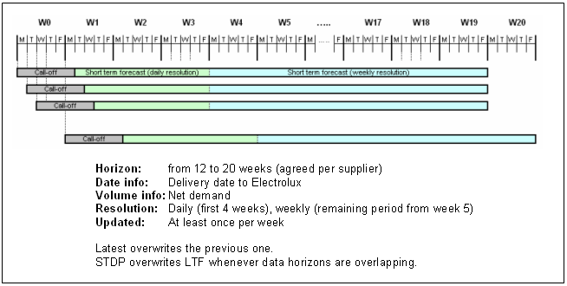

Long Term Forecast (LTF) - The long term forecast has to facilitate long term production planning and capacity management of the suppliers. LTF covers 52 weeks rolling period. It is updated weekly and provides gross demand with monthly resolution.

Delivery and Transport Data – This process supports the Supplier in the creation of dispatches, together with all the required documents/labels, including Bar-Coded Package labels (to the Odette standard) and the Dispatch advice documents.

Invoices – This process supports the Supplier in the creation of Invoices (computerised and in paper form), and the sending of these by internet to Electrolux.

Confirmation and respond times
After receiving LTF and STDP the supplier is expected to do a critical analysis of all part numbers taking into account its production capacity versus the total amount of parts forecasted by Electrolux. If the suppliers identify any risk of capacity problems, the supplier shall immediately contact Electrolux.

Silent commitment
“Silent commitment” is the way to avoid unnecessary volumes of communication. If supplier does not contact Electrolux within the following respond times (see below) Electrolux understands supplier is committed to satisfy in full and on time Electrolux requirements.

LTF – Supplier responds within maximum 2 working days from the date it was sent by Electrolux

STDP – Supplier responds within 24h from the time message is sent by Electrolux but not later than 24h before planned delivery date

Call-off – Supplier responds immediately from the time message is sent by Electrolux. In exceptional cases Electrolux might ask supplier for active confirmation (and related respond time)

The first login
For the first login, you will be informed about your user and password by the Electrolux Web EDI Manager
To make your first login, the following steps are necessary:
1. Start Internet
2. Please type in the Internet address http://wgate.electrolux.com/wGate/login.jsp
for the Electrolux portal. The following screen will be displayed:
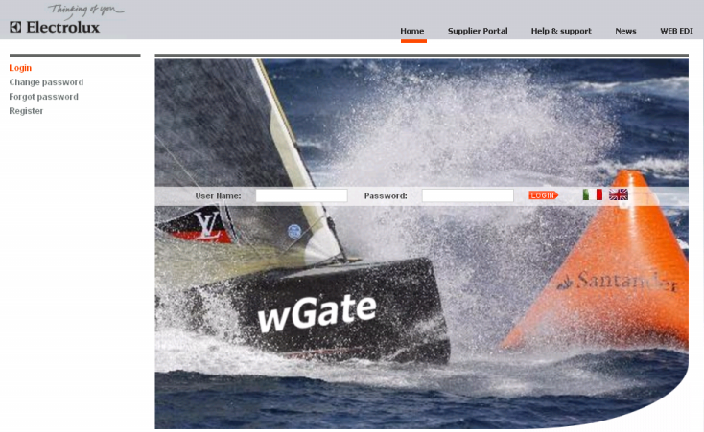
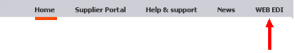
Now click on the WEB EDI link

The following screen will be displayed:

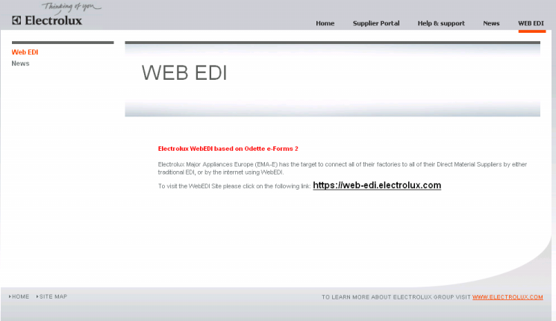

Click on the proposed link https://web-edi.electrolux.com

The system will be displayed the below screen :

Please enter your user name and your password in the designated fields. Please take care on upper and lower cases for the user and password. Then, click on the button Login

3. When you register for the first time, you will see once the following popup:
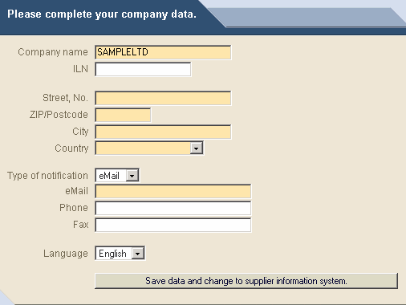

4. Please complete the information on your address. Mandatory are the yellow fields, the others are optional. In the following extract you can see an example of the address data fields.
It is absolutely mandatory that you choose as way of communication e-mail and that you enter your e-mail address in the corresponding field.
Note: Via this e-mail address, you will receive information the first time data has been provided for you in the internet. Also in the future, you will receive an e-mail as soon as new data has been provided for you in the internet.
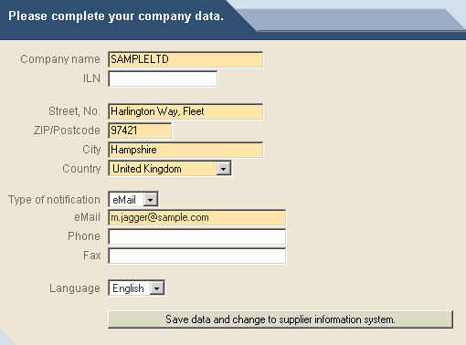

5. After having completed the address details, please click on the button ‘Save data and change to supplier information system’

Now you are in the main menu / start menu of the Web EDI application of Electrolux
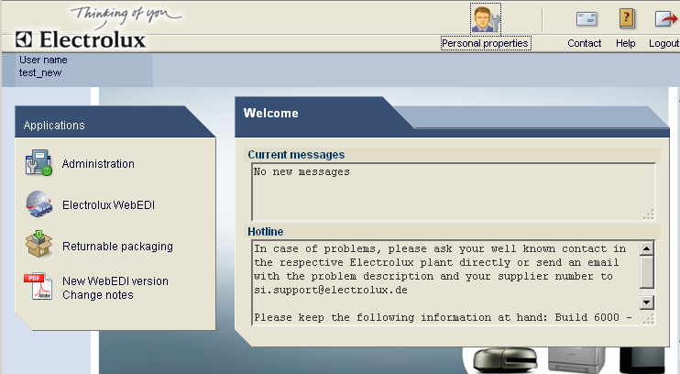

On the bottom of the screen, you can immediately change the language. In the address data, you can save your default language (so you will automatically start your preferred language on login)
Icons on the top of the page:
Select box : One of the ways to directly select a business process to work with
Personal properties : In the Personal Properties you can change your password or adapt your address
details
Contact : You can send an E-mail to the hotline of Web EDI. The address is hotline-
edi@electrolux.com
Help : Here you start the online help of the Web EDI application
Log off : You quit the Web EDI application of Electrolux

With this menu “Applications” you can select the part of application you want to work with.
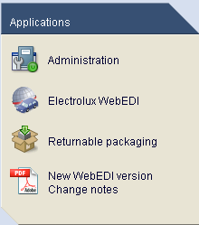
Administration : You can update Personal Properties and create Sub-user
Electrolux WebEDI : You can read messages form Electrolux and send DESADV and INVOICE
Returnable packaging : list of packaging material that is available over all Electrolux factories.

Change the user password
After having reached the Administration from menu of the Web EDI application for the first time, you should change your password in the Personal properties.
- Please choose the menu point Personal properties
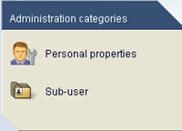
2. You will see the following window
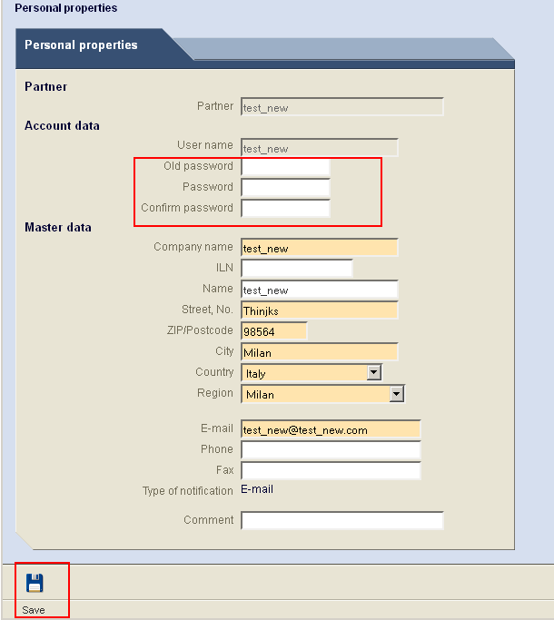

3. Please enter your existing password (Old password) and then in the following fields your new password (Password, Confirm password). After pressing the Save icon, your password will be changed. Please take care as these fields are Upper and Lower case sensitive

Change E-Mail notification
Web EDI automatically sends E-Mail notifications when data in the system is changed. You can control these E-Mail addresses directly.
The E-Mail address for the E-Mail notification can be set/changed using the user administration for the Web EDI main user.
The following steps are necessary:
1.Select “Personal properties”
2. Change the E-Mail address
3. Save data
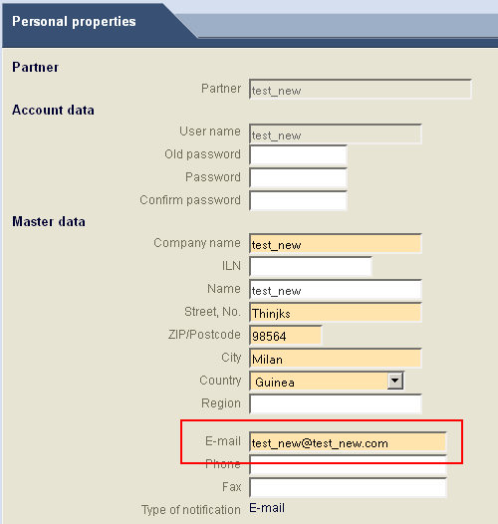

Sub-user administration
In the Sub-user administration you can create additional Users for your company.
Each Sub-user may be created with different access rights and a different e-mail address. For example you can create a sub-user, with only the rights to “display delivery instructions”.
Note the Sub-Users will also receive E-Mail notifications about changes to the Web EDI data

Please take care, that a sub-user can only created by the main user of Web EDI. Which is the
user, you get for the first time from Electrolux
When you want to create sub-user you need to go Administration -> Sub-user
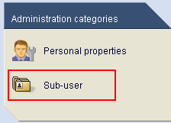

Click on icon New
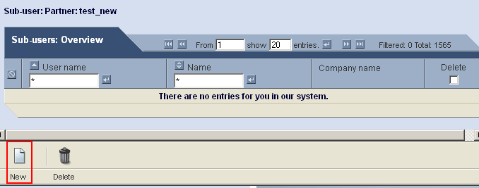
And complete all mandatory fields
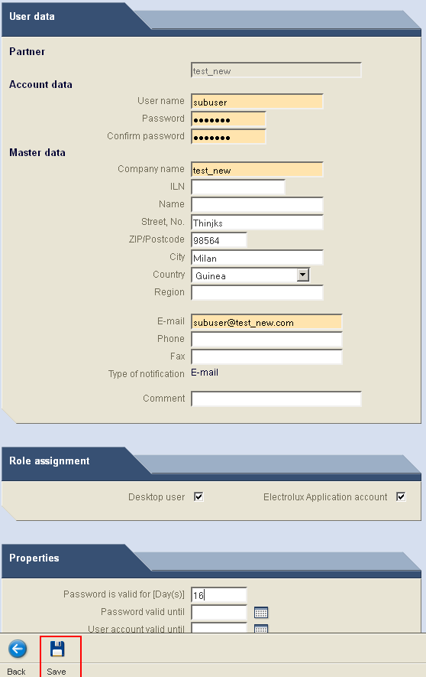
After pressing the Save icon Sub-user will be created.

Electrolux WebEDI
If from the main menu you will take Electrolux WebEDI all business processes available in WebEDI will be displayed
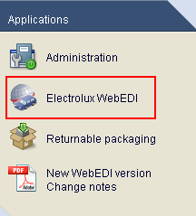

With this menu “business processes” you can select the business process you want to work with. The numbers shown in blue are the number of messages in this process that are still outstanding.
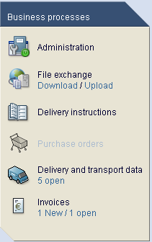

On this part of the screen, you will get an overview, about new messages and the last login.
In the area “Current information”, you will be informed about any extraordinary downtimes or planned maintenance of the Webbed Application.
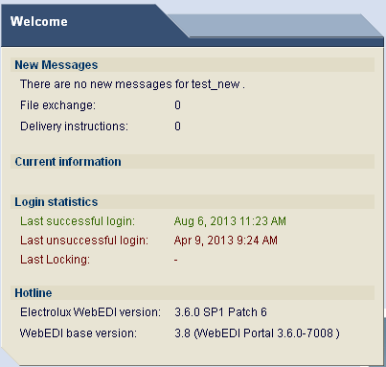

Display, print and download delivery instruction: (STDP short term delivery plan)
From the main menu select “delivery instructions”.
On the first screen, you will get a summary of all the different delivery instructions sent to you by all Electrolux factories. You will see the overview split by plants (factories) and the unloading points at the factory where the goods should be delivered to.
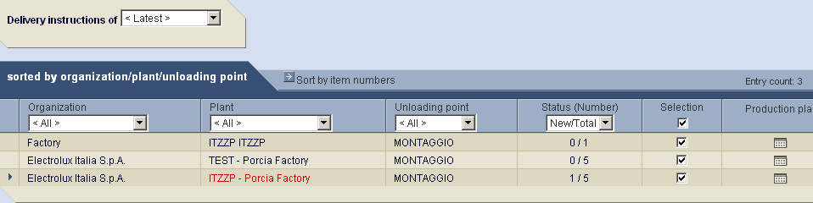
Using the select boxes you can filter the information you wish to see
The status box shows the number of new messages received, and the total number of messages in the system.

Mass print delivery instruction
For example, to display only the delivery instructions of the ‘SC’ plant, please select the plant SC : You will receive an overview on all items numbers for which you have received delivery instructions.
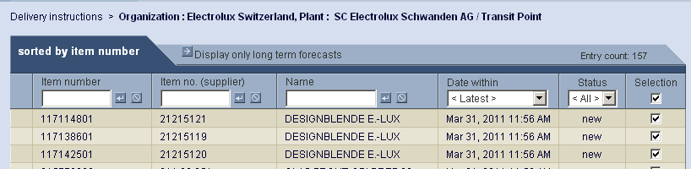

Note: The selection boxes are automatically set to “selected”, so all will be printed

Now if you select Status “new” you will print only the newly received delivery schedules.
Click on the button “print”. A new window will be opened and the printout will be available in a pdf-Format. Click on the icon “print” and all the new delivery schedules will be printed. 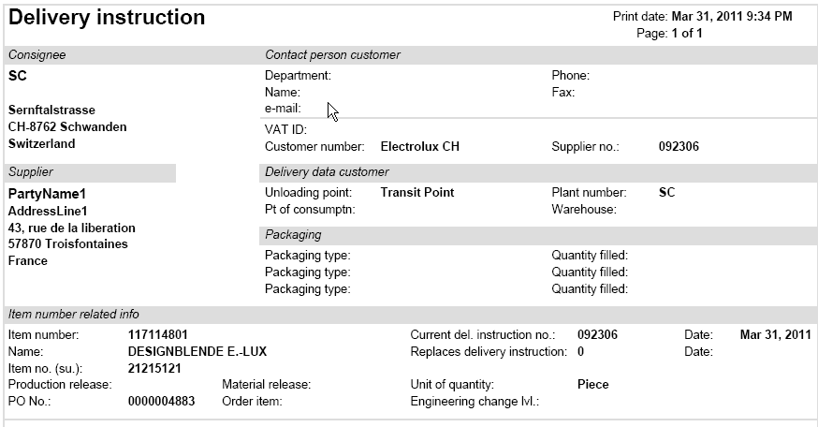
You can also enquire on individually selected delivery schedules, and print one by one.
If you click on an individual item number, you will simply see the information on the screen.
This information can also be printed by pressing the icon “print”.
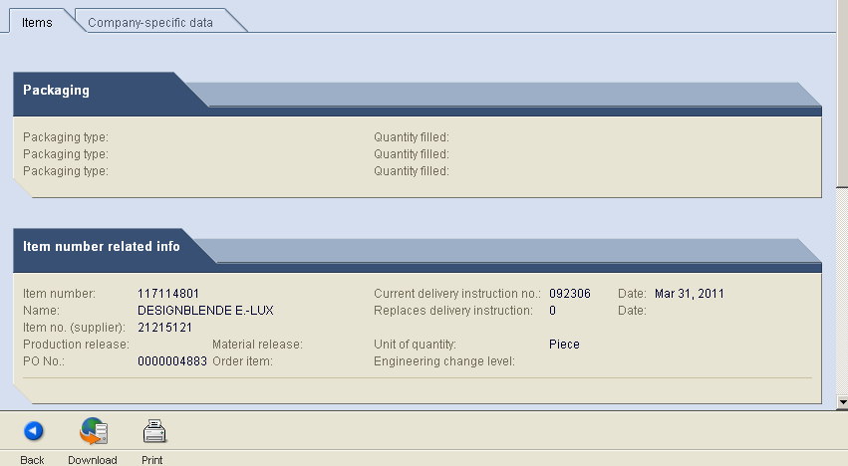

Display and print the production plan
You have the possibility to display and print a production plan for any plant / unloading point combination. With this function, you will get a simple overview about all demands in the short and medium term periods.
Data shown in the production plan reflect factory demand only. Previously sent goods in transit are not taken into account. Long term forecasts (lines in red colour) are not shown in the production plan.
Normal lines are for firm quantities and values marked by gray are for forecasts.
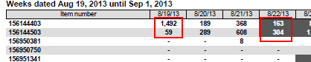

Selection screen for production plan:
To get the selection screen for the production plan, you have to click on the “production plan” icon on the plant / unloading point combination, you want to display.
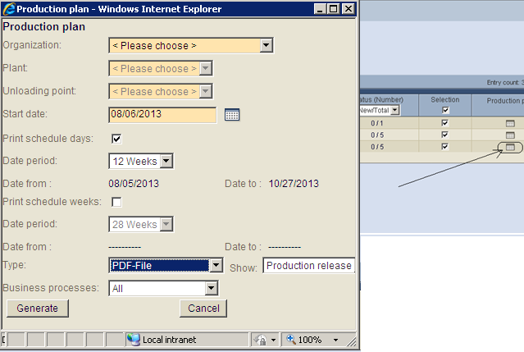
The default selections are:
- Start date is today
- The first 4 weeks are displayed in daily detail
- The following 28 weeks are displayed in weekly detail
The periods for days and weeks in the schedule can be changed with the selection box.
Also you can define, if you want to have only the day or the weekly schedule by clicking on “print schedule days” or “print schedule weeks”.
.Click on the button “Generate” to see the production plan.
Daily overview (First page if selected)
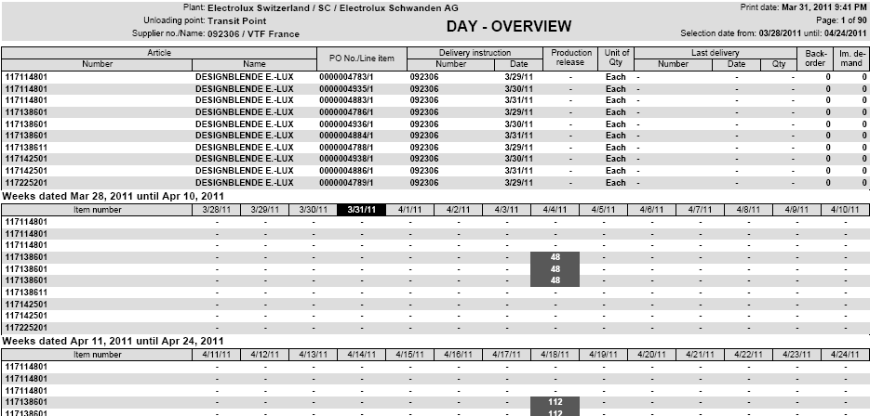
Weekly overview (second page – if selected)
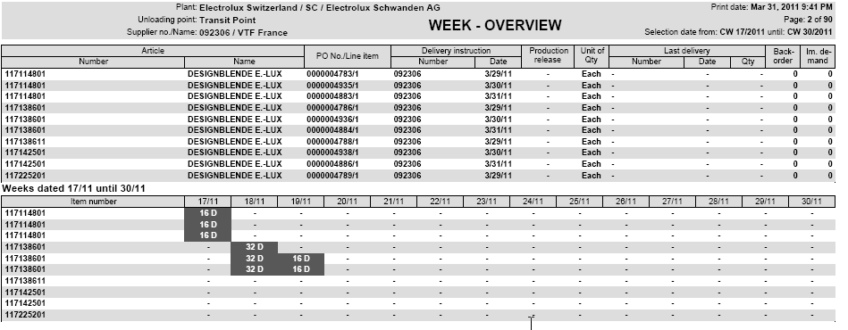
The Meaning of the letters after the quantity field:
D – Day -> Means in the weekly overview, the quantities have been accumulated from a daily level of detail.
W – Week -> Means in the daily overview, the quantity was really a weekly demand.
M – Month -> Means, the quantity was really a Monthly demand shown in the day- or week overview
X – Mixed -> Means a mix of different demand detail
The quantities are firm till the date of the production release

If you use CSV format you can move the production plan to excel format
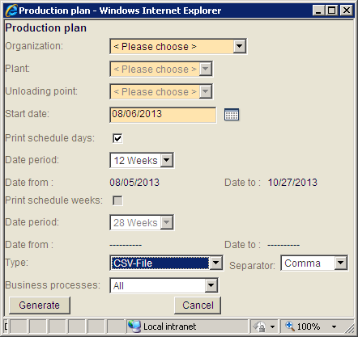

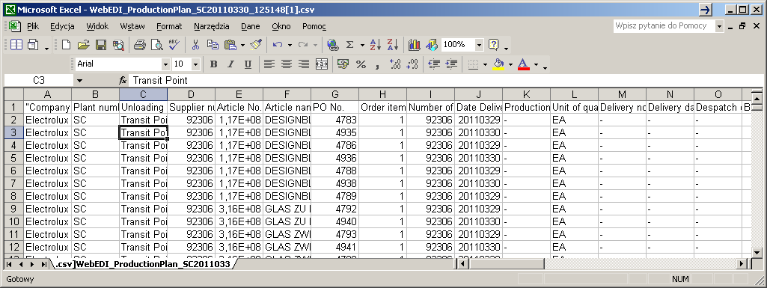

Production plan can be generate for all business processes or separate for Delivery instructions and separate for Purchase orders
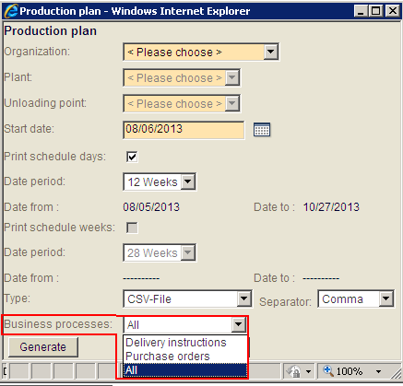

Download of message

Example Excel-download
For the delivery schedules and call-off messages, a download facility is available
Example for delivery schedules:
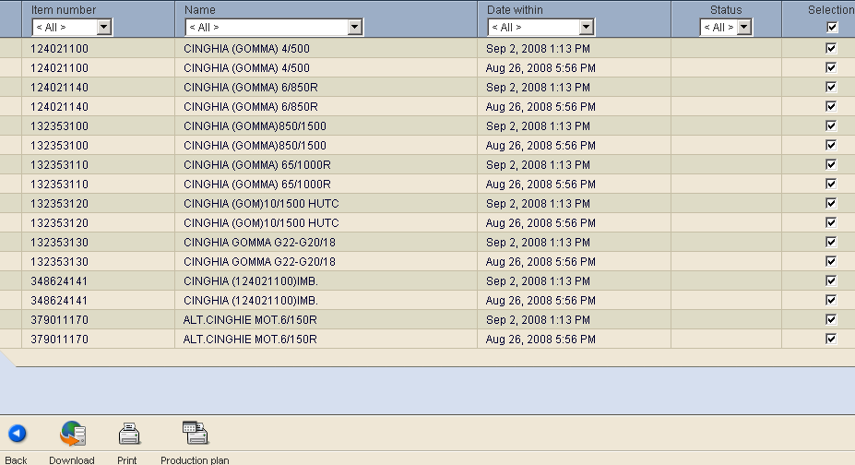
Select your delivery schedules for the download (or keep the default of all) and press icon “Download”!
The following pop up will open:

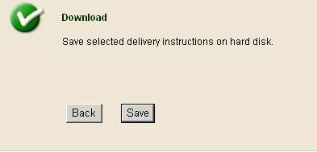

Please Press button ‘Save’ to save the data in CSV/Excel format to your hard disk.
An additional message comes
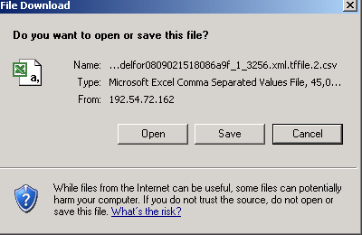
Choose the option ‘Save’ and the following ‘popup’ will be displayed
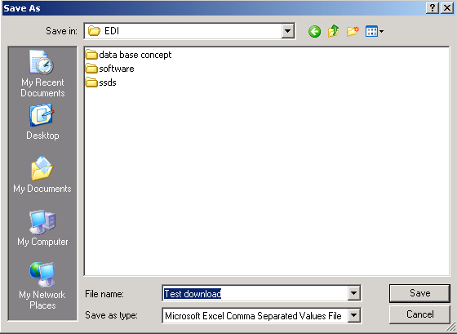

Select a file name and a place to save the data on your local disk!
The file will be saved on your local disk as csv file but when you double click on it to open it will be automatically opened in excel.

Call-Off Process

Introduction

Call-off plan is a part of short term forecast sent to supplier. Supplier has to dispatch / deliver parts to Electrolux in strict accordance with call-off schedule respecting quantity and dates. Under shipments and over shipments are not allowed. In case it is not possible by supplier to deliver agreed quantity on time it is the supplier responsibility to contact Electrolux at least 24 hours before shipment’s departure in order to agree how to proceed with the delivery.

Working with CALL OFF
Call-off message is well visible on the production plan as it’s displayed on white background .Please refer to chapter 8 for more details as all the steps (whenever working with Call-off) follows the same logics as in case of STDP.

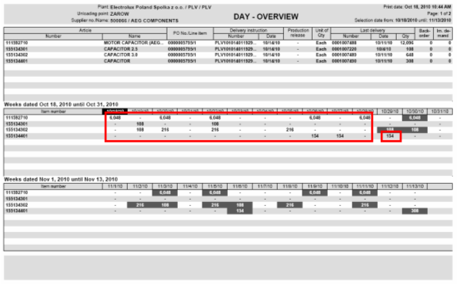

Purchase ORDERS
From the main menu select “purchase ORDERS”.
On the first screen, you will get a summary of all the different orders sent to you by all Electrolux factories. You will see the overview split by plants (factories) and the unloading points at the factory where the goods should be delivered to.
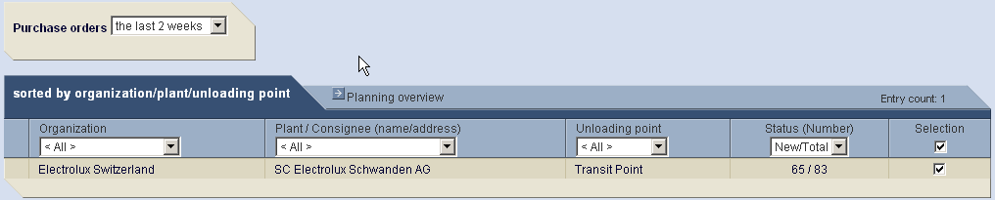
Using the select boxes you can filter the information you wish to see
The status box shows the number of new messages received, and the total number of messages in the system.

Print ORDER message
For example, to display only the ORDER message of the ‘SC’ plant, please select the plant SC: You will receive an overview on all Purchase order numbers for which you have received ORDER message.
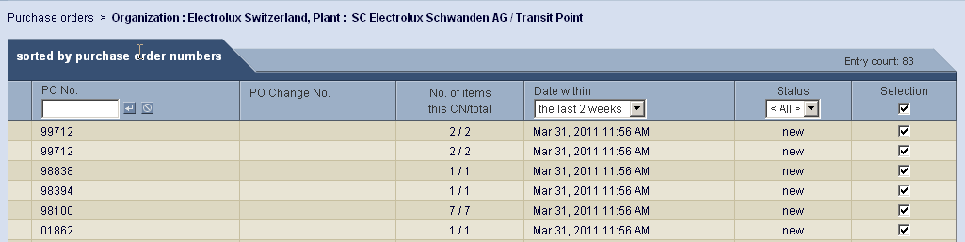

Note: The selection boxes are automatically set to “selected”, so all will be printed
Now if you select Status “new” you will print only the newly received ORDERS.
Click on the button “print”. A new window will be opened and the printout will be available in a pdf-Format. Click on the icon “print” and all the new ORDERS will be printed.
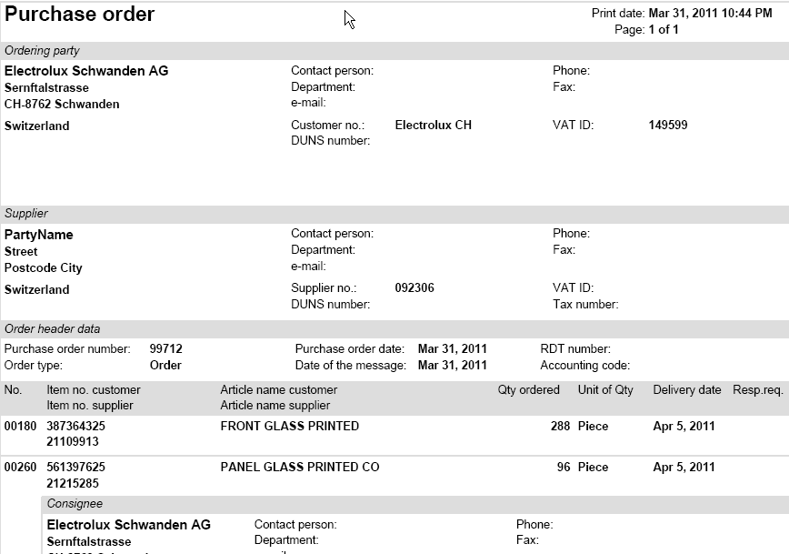

You can also enquire on individually selected ORDER, and print one by one.
If you click on an individual PO number, you will simply see the information on the screen.
This information can also be printed by pressing the icon “print”
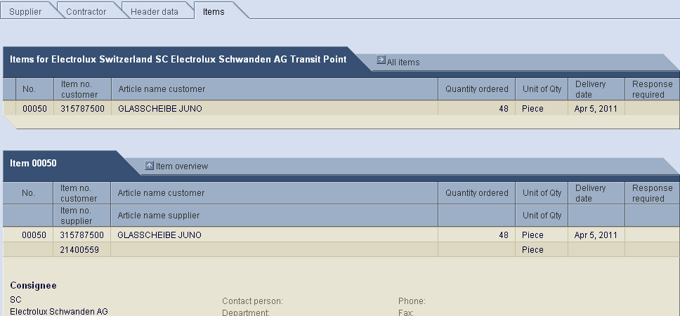

Download of message

Example Excel-download
For the purchase order messages, a download facility is available
Example for purchase orders:
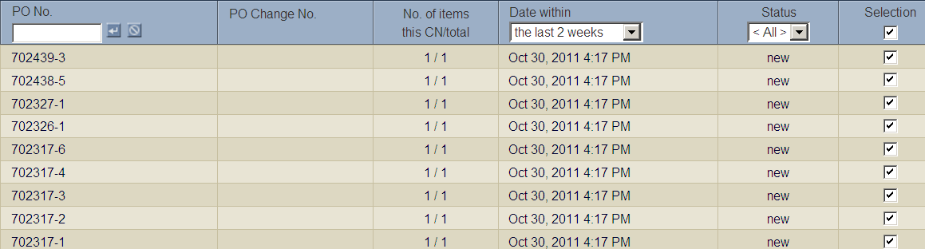
Select your purchase orders for the download (or keep the default of all) and press icon “Download”!
The following pop up will open:

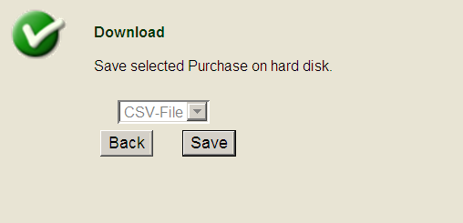

Please Press button ‘Save’ to save the data in CSV/Excel format to your hard disk.

An additional message comes
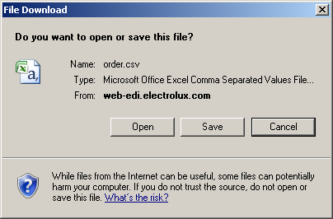
Choose the option ‘Save’ and the following ‘popup’ will be displayed
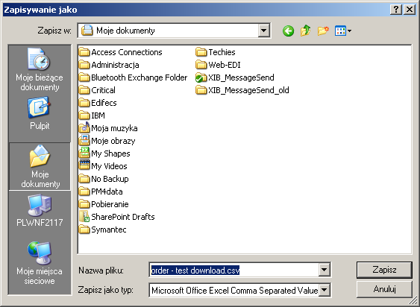

Select a file name and a place to save the data on your local disk!

Delivery and transport data
Creating and manipulating delivery records is the focal functionality of WebEDI.
WebEDI is an extremely flexible tool allowing you to reap all the benefits of automatic records creation as well as ultimate freedom of manual adjustments. Provided that you have all the prerequisites ready, creation of a new shipment can take as little as five minutes. The general process of a shipment creation and modification is described in Chapter 10.1. For a fast track example, refer, please to chapter 10.4.
In order to work in the most efficient way with WebEDI it is mandatory to store packaging master data for each product you deliver to Electrolux. These data, once entered into WebEDI are kept in the database for all subsequent use. Chapter 10.2 has all information on managing packaging and weights master data.
Based upon the entered/stored data Web EDI automatically generates a proposition for the structure of the shipments along with automatic calculation of all weights. You are free to accept that proposal or completely change it in a manual mode.
Once you entered and verified all the information it is easy to print required packaging labels according to the Odette standard. Chapter 10.3 shows how to print such labels for a shipment.

Shipments
By clicking on Delivery and Transport data section link on the main screen of WebEDI application or choosing this option from the drop down box on the top navigation bar you are transferred to the next screen, which has three sections
New shipment to – this section provide you with various options to create a new shipment.
Open shipments – all created but not send shipments listed in this section. You are able to introduce any changes or delete them.
Sent shipments – once you completed shipment and pressed Send button the system automatically creates EDI message and sends it to Electrolux. The shipment record becomes unavailable for edit and is listed under Sent shipments.

Creation of new shipment
Within WebEDI you have four options to create a shipment:
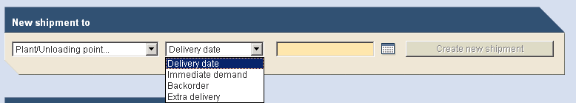
Shipment type | Description
Delivery date | WebEDI application automatically proposes a shipment based on the firm quantities of the latest delivery instructions/call-offs. The date of the shipment is the earliest date to deliver according the call-off. Backlog data are taken into account too.  Once you created and sent the shipment it is not possible to create any more shipments for this date using this option.  This is recommended option to create shipments.
Immediate demand | WebEDI application proposes only the quantities of call-offs, which are marked as immediate demand or backorder.
Backorder | WebEDI application proposes only the quantities of call-offs, which are marked as backorder.
Extra delivery | By selecting this option you are able to create the shipment on your own.  Please, note!  Quantities in Extra delivery shipments do not change demand indicated in the delivery instructions. Therefore, if you later create another shipment using Delivery date option, the system will not take into account quantities already sent in Extra delivery shipments.  We recommend using Delivery Date option when creating shipments. Use Extra Delivery option only when necessary.

Editing shipment
Once you chose the shipment type the following screen appears.
It has Shipping number field, three tabs where all shipment data can be entered and stored and the lower bar with function buttons.
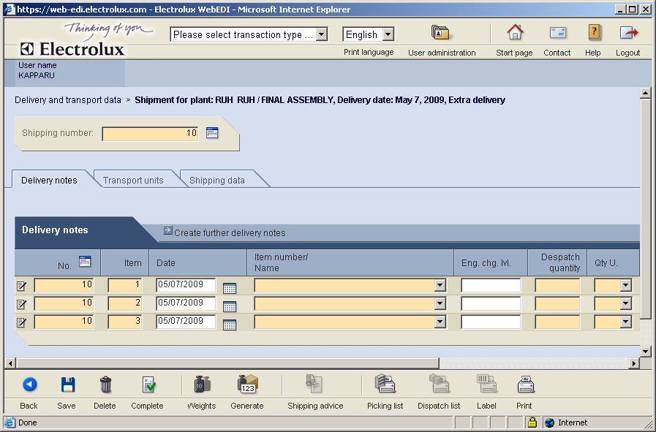

Shipping number – you have to indicate your alphanumerical number.
Delivery notes tab has a table where all the data regarding content of delivery are entered.
Transport units tab helps managing the way the goods are packaged in the shipment.
Shipping data tab provides with input fields for shipment header data.
Definition of the following ICONS:
Back – allows you to return to the previous screen.
Save – saves all the data in WebEDI database.
Delete – delete the whole shipment.
Complete – checks the completeness of shipment data and making it available to send.
Weights – Used to calculate the weights for the entire shipment, i.e. weights of all delivery note items and the corresponding packages.
Generate – based on existing master packaging data the system arrange goods in packaging units.
Shipping advice – Can be used to complete temporarily stored in the cache and to display advice that has been sent.
Picking list – This allows you to select the shipment you would like to print a picking list for in the table of open shipments.
Dispatch list – This allows you to select the shipment you would like to print a dispatch list for in the table of open shipments.
Label – The Labels button is only active if you are on the Transport Units tab or in the Editing Delivery Notes dialog box. You can also print labels when you have completed and sent a shipment.
Print – Selecting the Print function displays the print view of the shipping advice in a separate window

Delivery notes tab

The central item of this tab is the table that has information rows about goods in the shipment.
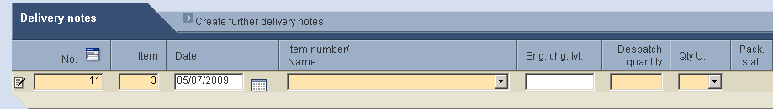
Edit line – clicking on this icon invokes the screen with advanced packaging parameters and properties of delivery item.
No. – Delivery note number. This automatically generated delivery note number is used as the reference for the invoice and should be not longer than 10 digits. Normally, you have to fill in the same delivery note number in each line. For each delivery note number an inbound delivery is created when sent to Electrolux.
If you simply create a shipment using option Delivery date, you can allow the WebEDI to generate the number automatically. In case you need to align WebEDI data with another system you need to enter the number manually.
To enter the number manually you have to click on the icon next to the title of column No. The following popup screen allows you to type in the prefix.
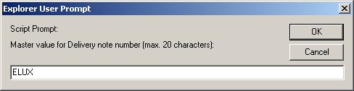
Type in the Alpha / Numeric you require.
Then you have to click on the button ok to confirm this prefix. Each time, you want to change this prefix, you can follow this procedure again. The prefix will be added to the delivery note number that you send to Electrolux.
Item – ordinal number of the line in the shipment
Date –
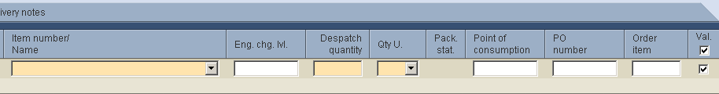
Item number/Name – Electrolux code of the component (ANC) and name
Eng. chg. lvl. –
Despatch quantity – Quantity of the component in the shipment.
Qty U. – Unit of measure
Pack. stat. – Status of packaging information of the item
Point of consumption –
PO number – Electrolux purchasing order number to which this shipments belongs to. This is pre-filled in from the DELFOR
Order item –
Val. –

By clicking on Create further delivery notes link you can add some more lines to the delivery data. In order to delete a line from the shipment, choose empty space in Item number/Name drop down box. The system saves the only lines where item number is defined.

Transport units tab
Whereas Delivery note tab provides you with information about the articles and their quantities in a shipment, Transport units tab helps in managing the structure of the shipment. In other words, it is possible to see here how goods are packaged.
Normally, based on packaging master data the system automatically generates the required number of exterior packages to accommodate components. It can be done by clicking on Generate button.
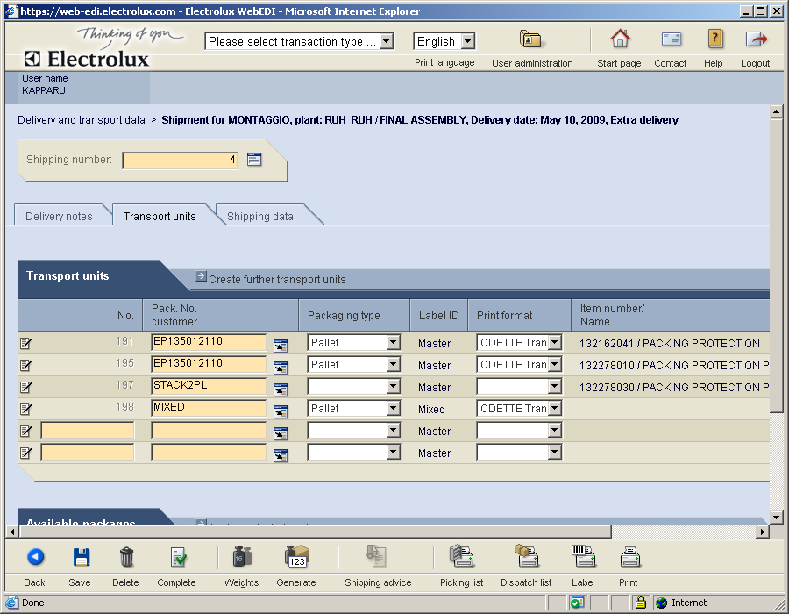
However, there is a possibility to add new transport units, place interior packages on them. You can completely rearrange locations of interior packages within transport units, even combining packages of different articles in one transport unit. Not needed units can be removed from the shipment.

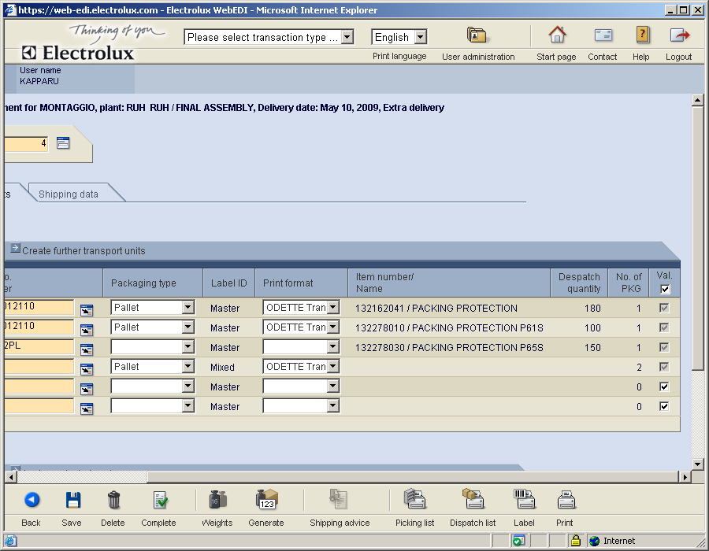

From now on the WebEDI-System automatically provides a list of packaging material that is available
over all Electrolux factories. List of returnable packaging is available Under “Pack. No customer”.

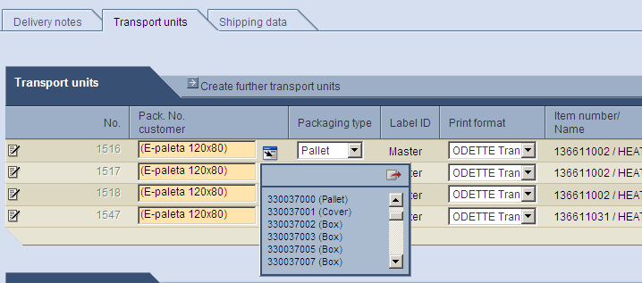

Description for it is available on front page under “Applications”

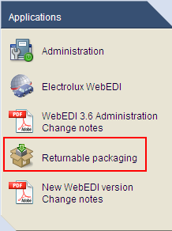

Shipping data tab
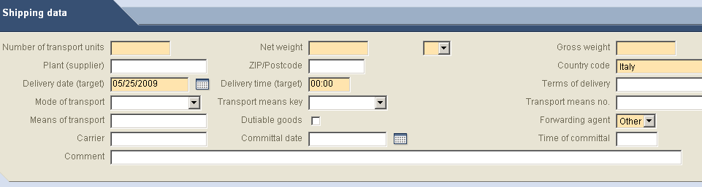
Within the Shipping data tab, a user determines the following values Mandatory values.
Number of Transport units:
Net Weight in kilos:
Gross Weight in kilos
Plant (supplier)
Terms of Delivery:
Mode of transport:
These values will then be copied into the invoice at a later stage.
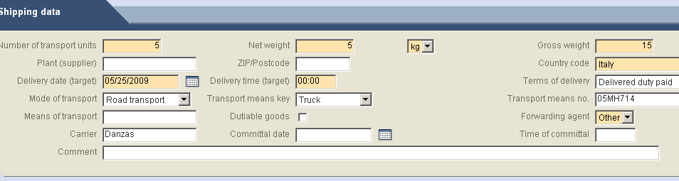

Finalising shipment

Once the user has keyed in all the values relating to the shipment and pressed the “SAVE” icon. You now can press the “COMPLETE” icon 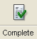

The following icons will now appear.

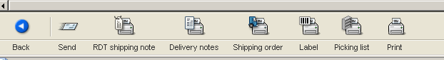
All of the above icons when selected will print documentation which can be used in the transportation of the goods:

The icon will send the Dispatch advice to Electrolux.

Packaging information

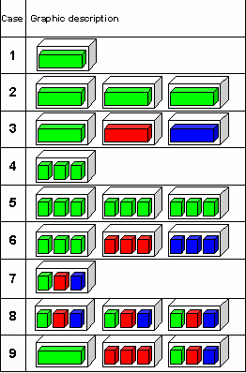
WebEDI can manage all packaging data, with the automatic generation of packaging labels and shipping notes.
It is even possible to manage mixed pallets (containing different mixes of components and boxes within the same transportation pallet).
Each colour represents a different product.
To make this process more understandable, we have also made some examples beginning on chapter 9.2.
There are three types of packaging which can be defined in WebEDI.
Inner packaging – containers that have components themselves inside (e.g. boxes of components)
Exterior packaging – containers that have inside inner containers (e.g. pallets, containing boxes of components inside)
Intermediate – not used

Creating packaging instructions
Having all packaging instructions stored in the system facilitate creation of dispatch advices. Packaging information data are entered into WebEDI during the process of creating a shipment. Once entered, they are kept in the system.
You may want to have these data entered into WebEDI in advance. You can achieve that by creating a ‘virtual shipment’ using delivery date option Extra Delivery.
To enter packaging information
- On Business processes menu click on Delivery and transport data.
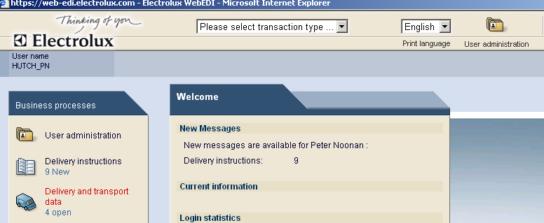
The following screen will be displayed.
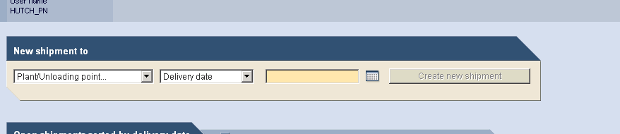
- Now select the appropriate Plant/Unloading point and option Extra delivery and click on the button Create new shipment.
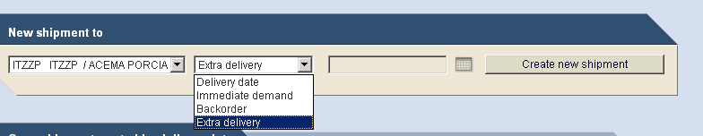
- WebEDI will display the following screen, where you can select an article and insert the packaging instruction for it.
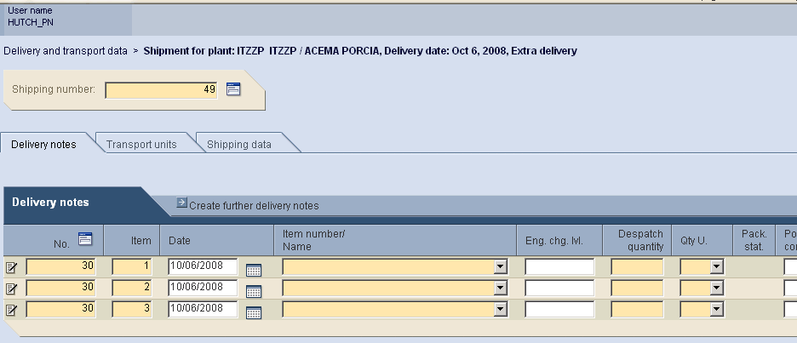
- Choose appropriate item from Item number/Name list box. WebEDI will display the article requested by Electrolux.
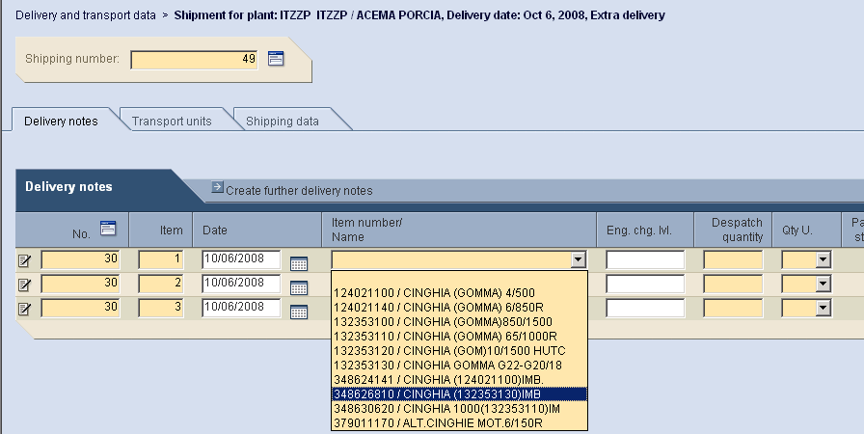
- WebEDI will inform you if the packaging data have been defined or not.
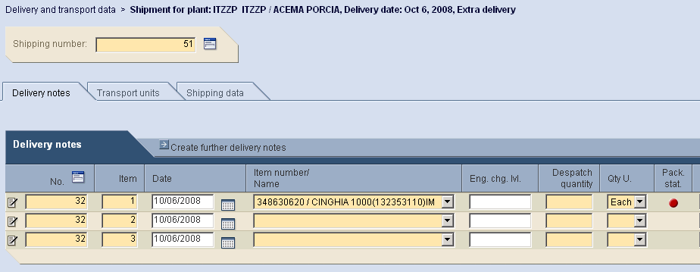
The status of packaging information can be seen in the column Pack. stat.
No packaging data are present for the select article. This is only a warning sign and can be ignored, if the article you are delivering has no inner or outer packaging.
The packaging data are already present in the system for this article.

If WebEDI informs you that there isn’t any packaging instruction data (e.g. the dot in the column Pack. stat. is red), you need to follow the next indications, otherwise means that packing data are present and therefore you can skip the next instruction.

- To insert the packaging instruction you need to click on the red dot in the column Pack. stat. and the following screen will allow you to insert the packaging data for the chosen article.
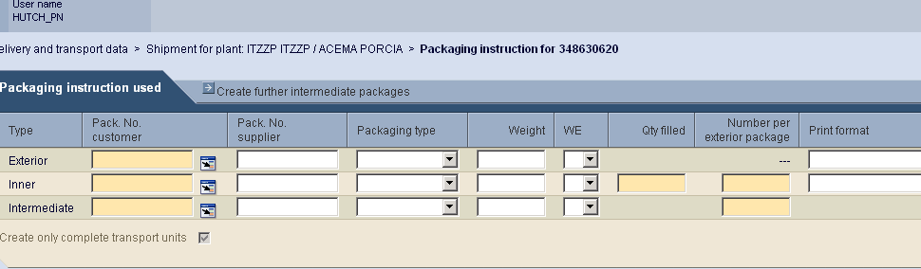
Complete the packaging data as described in paragraph 10.3.2 Packaging information in details

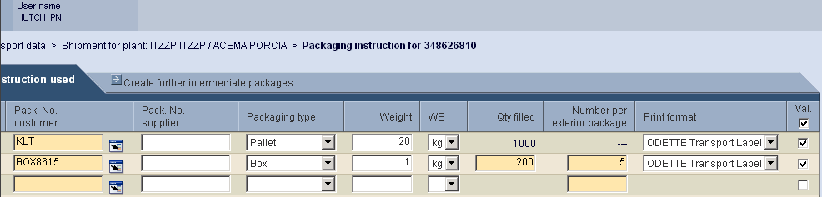
- Now click the button Save in order to save the packaging data.
An information window will appear informing you that the data are saved. Use Back button to go back to the previous screen.
Now, the dot in the column Pack. stat. is orange.
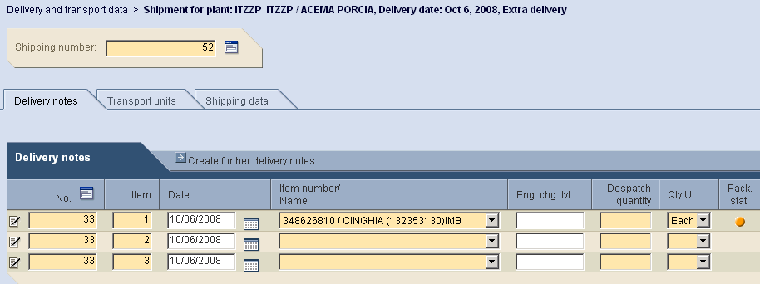
- Repeat the same activities for all articles.

Packaging information in details
Each time there is a need to create, assign or modify packaging instructions of a component Packaging instruction screen shall be used.
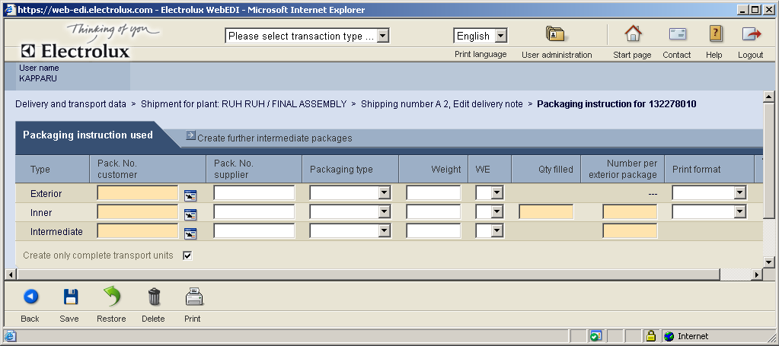
In case no packaging data is linked to a component the input fields are empty. There are two possibilities to assign such data to the article.
It’s possible to select them from the lists of previously created packaging rules. You can achieve that by clicking Select from list icon.
Alternatively, you can simply enter all required information into Packaging instruction used table.
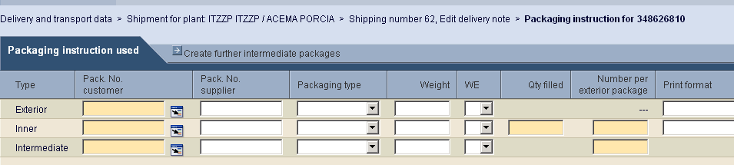
Just go into the appropriate packaging rule line and type in a new rule name into the Pack. No. customer input box for Inner and Exterior rows. Intermediate row is not used.

You may need to enter data to some other fields, whose descriptions are as follows

Weight – packaging weight
WE - Unit of weight measure
Quantity filled – number of items per package
Number per exterior package - how many pieces of inner packaging make up an exterior one
Print format – choose mandatory value ODETTE transport label from the drop-down list box
Insert the data for exterior package if the article should be packaged in external package
Print format – choose mandatory value ODETTE transport label from the drop-down list box

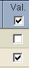
Tick the checkbox in the column Val. If the article has an exterior package, tick Val. checkbox in the line for exterior package as well. Otherwise leave it empty.

Clear or tick Create only complete transport units checkbox.
If the checkbox is enabled, the system will place the inner packages inside the exterior ones, only if the quantity of interior packages results in a complete exterior package. If the supplier wants to have also incomplete exterior units (not completely filled) it has to disable this checkbox.

This new packaging rule will be available for selection after you have saved the package instruction.

See the below example:
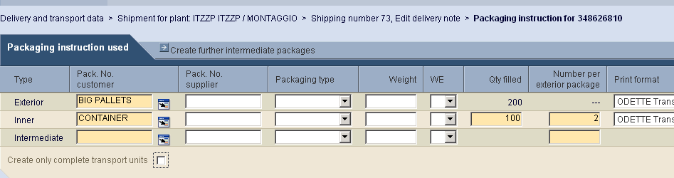
Now, click Save button and the new inner and exterior packaging will be included in the drop down list box.
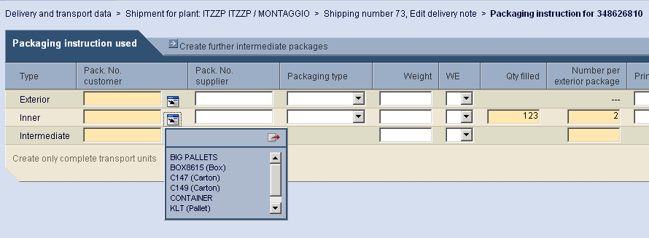

For managing packaging rules combination as a whole there is a function bar in the bottom of screen.
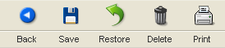
Back – allows returning to the previous screen.
Save – saves all the data in the WebEDI database.
Restore – cancels all the modification you have done and not saved.
Delete – delete the whole information about packaging of the component.
Print – allows printing packaging rules of the article shipment.

Updating existing packaging information
Each time new shipment is created or another article is added to a shipment, WebEDI by design checks if there is applicable packaging rules defined for the articles in the shipment.
If it is not the case, then a red dot appears in the relevant shipment line and it is possible to enter Packaging instruction screen by clicking on it. Further actions are described in 11.3.2 Packaging information in details.
In case the applicable packaging rules are found for the article, WebEDI automatically links these rules to the shipment line, thus facilitating future generation transport units’ information. An orange dot then can be observed in the relevant position.
You may need to update packaging information for an article. To do this you need first click on Edit line icon. Edit delivery note screen with advanced parameters will open.
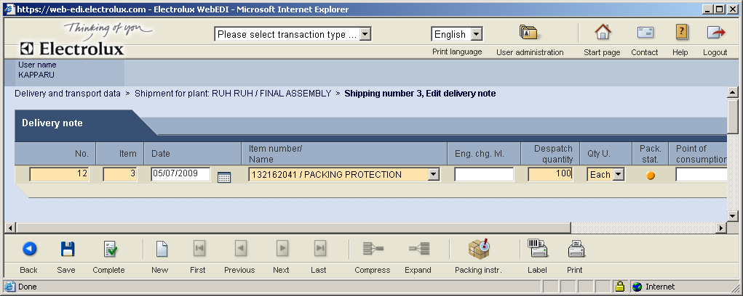

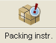
By clicking on Packing instr. icon Packaging instruction screen opens allowing edit of packaging rules. Further actions are described in 11.3.2 Packaging information in details.

Please, note!
You can keep only one combination of packaging rules for one component in the same time. Once you enter new interior or exterior rule, even with different Pack. No. customer the old one disappears.

Configuring data for automatic weights calculation
Web EDI can automatically generate all the weights of the shipment based upon the entered/stored data. You can check whether the weight data exist in the system by clicking Weights icon on shipment creation screen.
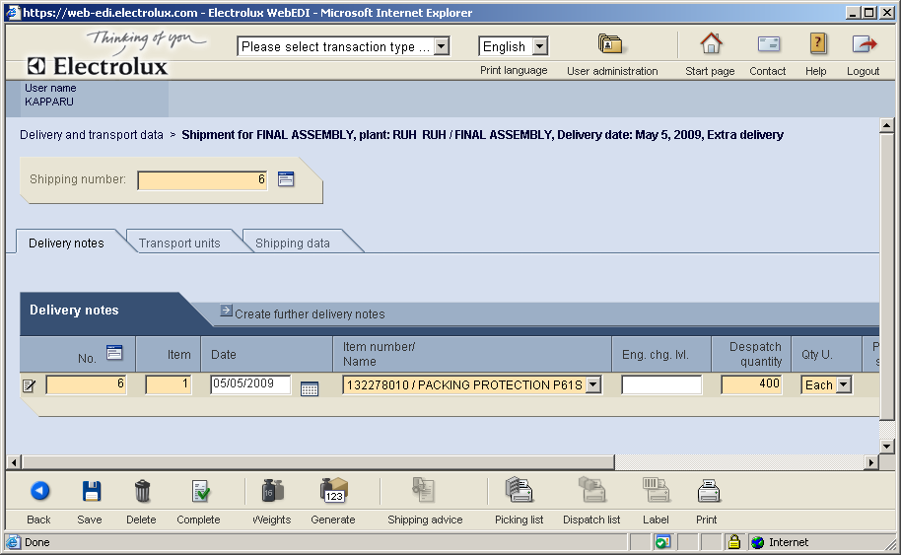

If you get the following warning message you can either ignore it or you can input the weights for the packaging and the products that will be kept for future use. You may also manually insert total net and gross weights of the shipment.

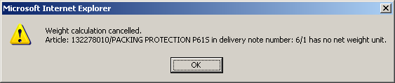

To insert weights of articles and packaging click Edit line icon.
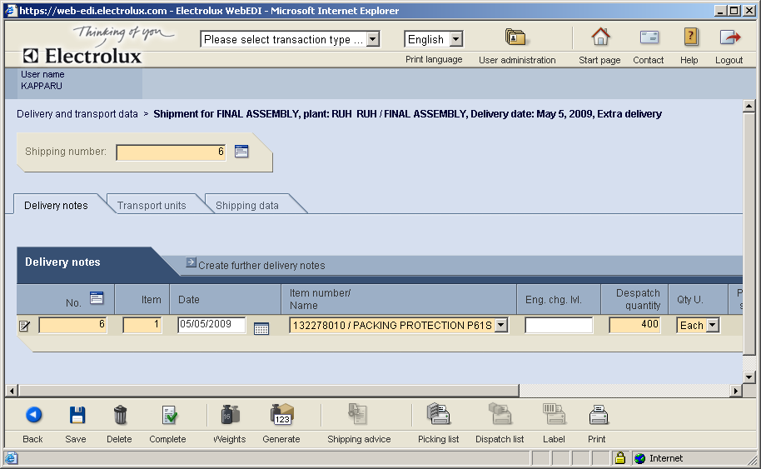

Edit delivery note screen with advanced parameters will open.
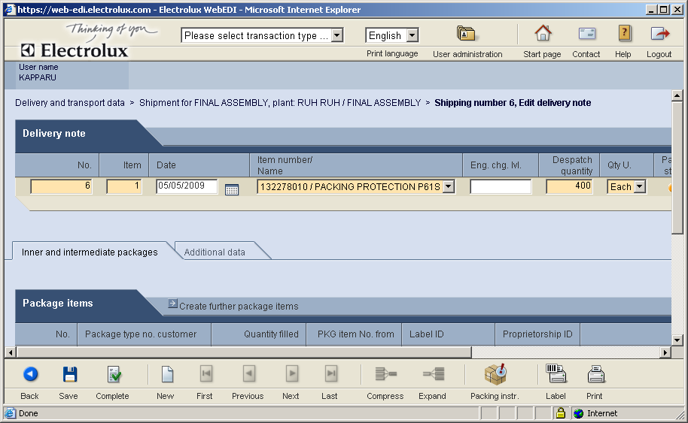

Select Additional Data tab and enter net weight of the article.
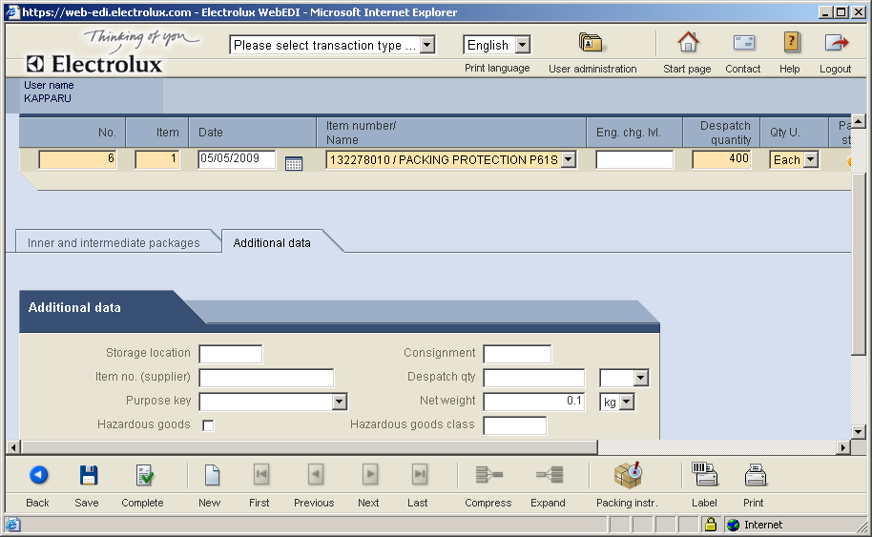
Check also the weight of the packaging. Click Packing instr. Icon

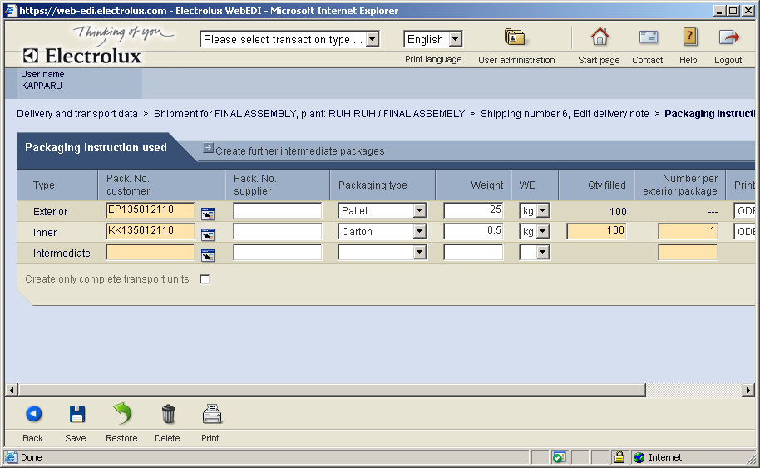
If you change anything in the packaging master data make sure you save it before going back to the main screen.
Go back to shipment creation screen and select Shipping Data tab. Click Weights icon on the functions bar in the bottom.
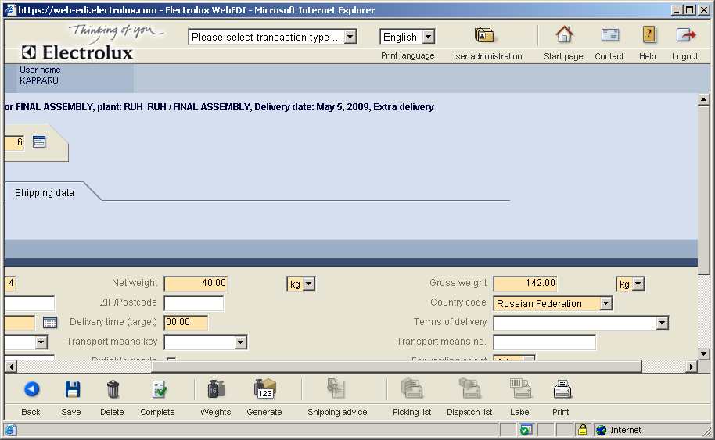
Now, you can see net and gross weights of the shipment.

Labels
Electrolux requires that every component shipment to its factories shall be marked with labels according Odette labelling standard. WebEDI allows printing these labels for both interior and exterior types of packaging. An example of the label is shown here.

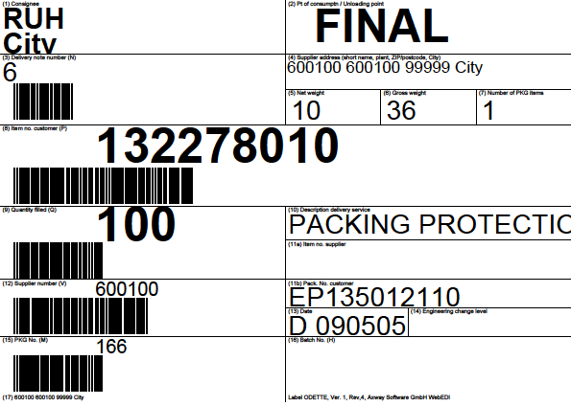

The option to print labels becomes available when Complete button is pressed on the shipment creation screen. The system then calculates required number of transport units of each kind and assigns them appropriate numbers.
As a result Label button becomes available.
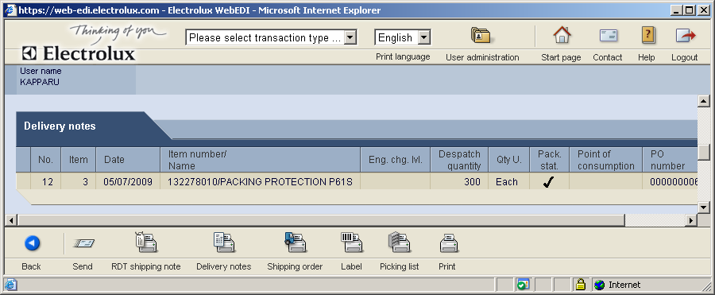
Clicking on Label button activates screen with label printing parameters.

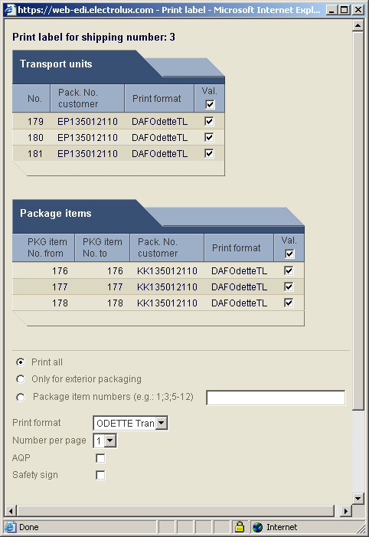
At this screen you can select which labels to print, label format (use Odette) and some other parameters.
The result is the file in PDF format that can be send to printer or saved for future use.

Example 1. First shipment with the completion of the packaging master data

Information about the packaging

50 pieces
Per box

code 379011170 ALT.CINGHIE MOT.6/150R
Pallet

Electrolux has requested 1 pallet with 9 boxes of 50 pieces of the reference code 379011170 ALT.CINGHIE OT.6/150R each. The total quantity is 450 pieces.

Start with shipment
Select the process Delivery and transport data.
To create the shipment in this example you have to select the plant and unloading point and have to choose the delivery option Delivery date. The next date to deliver will be proposed automatically.
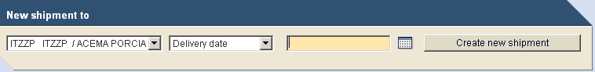

Now, click on the button Create new shipment
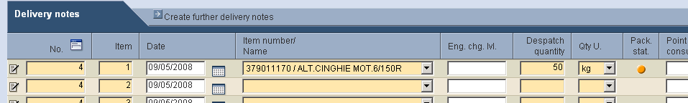
You will get the shipping proposal with the packaging status .
Where the shipping proposal with the pack status is and the article requires no inner or other packaging please ignore the Icon and proceed.

The following “pack statuses” are available:
– No packaging master data is available for this reference. This is only a warning message.
– Packaging data is available, but not generated yet for this shipment
– Packaging data is available, but not all inner packaging are linked with exterior packaging.
- The packaging master data are not finalised. No outer or inner packaging is defined. Correct the packaging instructions and click Generate again. Or, ignore and proceed.
- The packaging master data are complete, but the ordered quantity is not aligned with the packaging instruction. Select Transport units tab and finalise the packaging manually.
– The packaging master data are available and shipment is successfully “packed”
To continue with the first shipment, you have to connect one-time the packaging master data with the exterior packaging.
Click on the “edit delivery note item” of the reference you want to update the packaging master data.
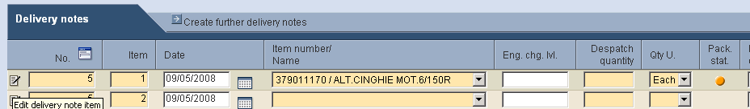
On the next screen, please click on the icon Packing instr.

Update packaging master data
You will get the following screen to update the packaging instruction.
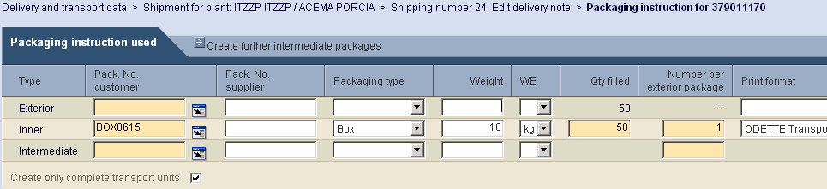
The inner packaging is shown according to the last delivery schedule. Please, check also, that the correct label format is linked with the packaging. (In the example Odette transport label)
Now, you have to add the exterior packaging and link it with the correct bar-code label
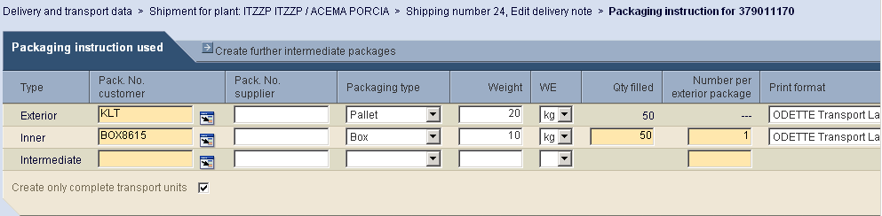

Continue with the shipment
Now, you have to enter the delivery note number and click on the icon Generate in order to link the shipment with all the packaging, based on the latest packaging instruction information.
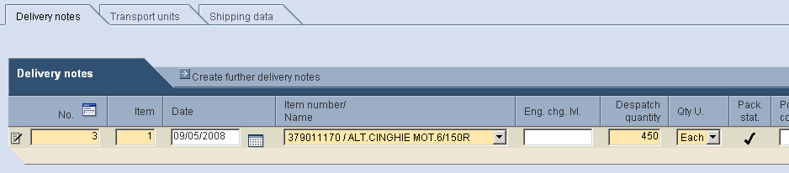
The packaging status changes to
Now, you could also print the picking list. It can be used by the warehouse personnel to pick the products.

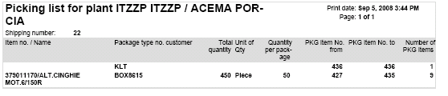
On this list you can see the link between the label number for inner and exterior packaging. This information is important, so that after printing the barcode labels, you know where to stick the correct label to the physical packages. (Especially, if you have more then one handling unit for the shipment)
Please, note!
If you generate the labels again, the label numbers will be changed and you will have to print the picking list again.
There is an optional function to view and manipulate the packaging for the shipment, (which was automatically proposed, based on the packaging master data)
Please select Transport units tab.
Not necessary for this example
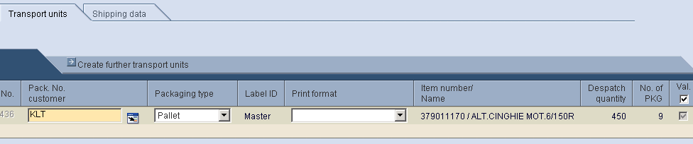
You can see 9 handling units, each with the quantity of 450 pieces. When you click on Edit external package, you will see the inner packaging is linked with the exterior packaging.

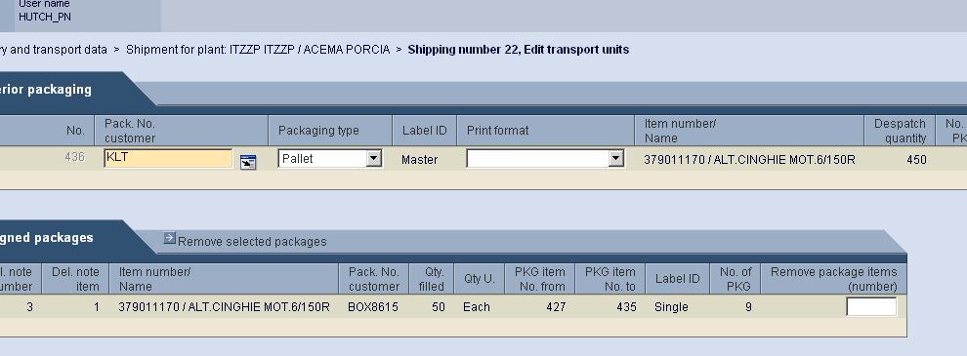

The unique label number is 436 for the pallet (exterior packaging) and from 427 to 435 for the boxes (inner packages) on this pallet.
At this point it is also possible to manipulate/change the packaging. For example; you can remove boxes from pallets and add them to another pallet. You can also create new pallets and so on. This is mainly necessary, when you are working with mixed pallets (and the automatic generation needs to be adjusted).
With one click back, you can move back to the main screen for Transport units.
Select Delivery notes to complete the shipment.
The net weight and the cross weight will be calculated automatically (if the weights for the packaging and the products are stored in the master data). If not, please enter manually.

Manually update shipping data
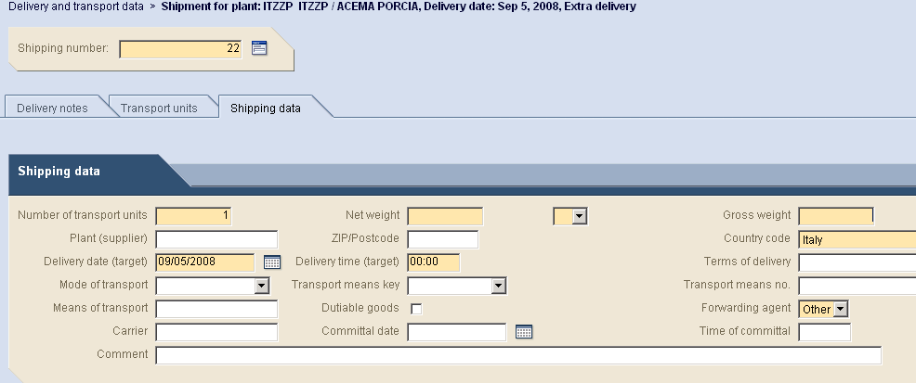

Enter the net weight and the gross weight
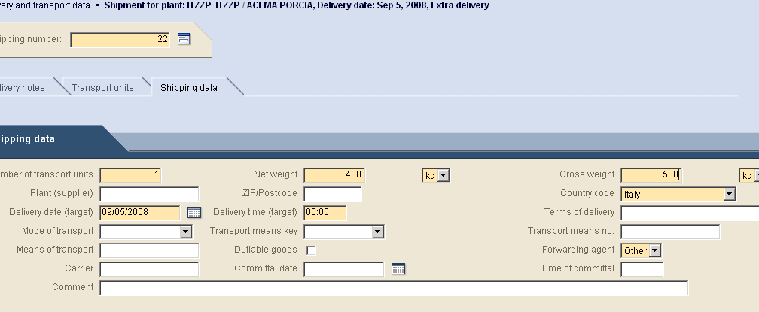
And click Complete
The following screen will be shown with or without packaging information, as this is dependent on the type or article being delivered.
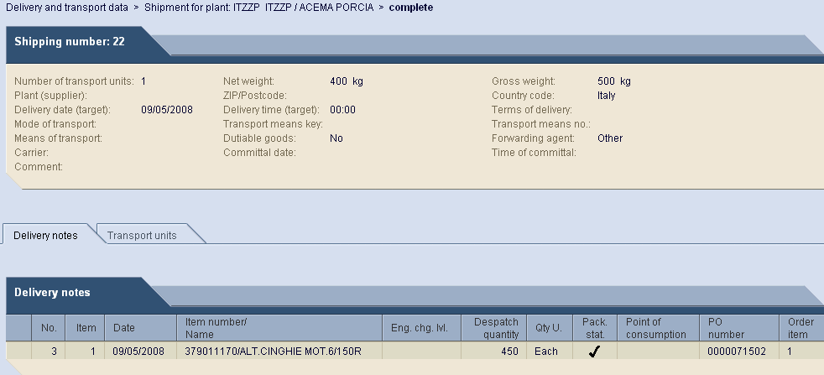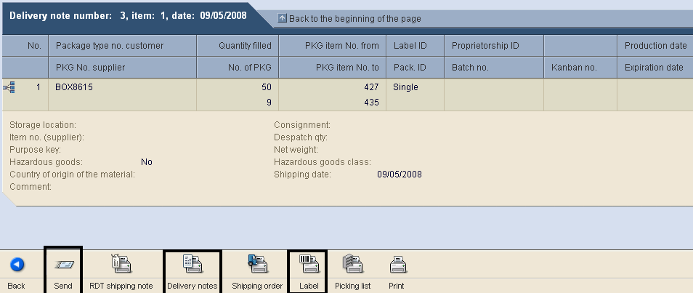
Here you can check again your shipment, if you want to change anything, you can go back. If OK, you should do following steps:
1. Print delivery notes (optional)
2. Print all labels
3. Send the shipment
Please, note!
After sending the shipment it is no longer possible to make any changes. In case of mistakes, please contact the receiving area of the corresponding Electrolux plant.

Print delivery note
Click on the icon Delivery note

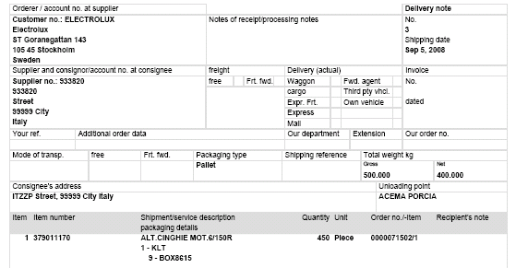

Print barcode label
Click on the icon Label and select printing parameters. In the Print format box you need to select ODETTE Transport label.
WebEDI will print one label for pallet and 9 labels for boxes. See the example.
The label for the pallet
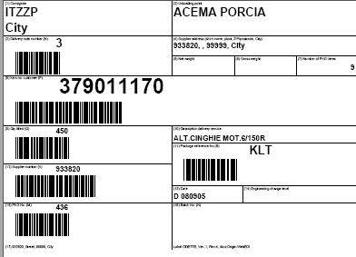
The label for the boxes
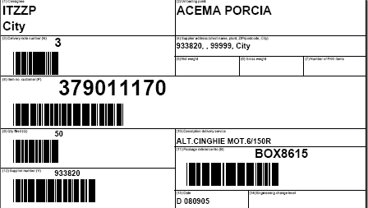

Finalize the shipment
Click on the icon Send. The Electrolux plant will receive immediately an electronic message.
If you want to continue with creating the invoice, you can click on the icon Invoice. If not, click on the icon Back. Invoice can be also created later, if you are not working with self billing.
Attach the labels with the correct label number on all the packaging based on the picking list. The physical packaging must match with the electronic message sent to Electrolux.

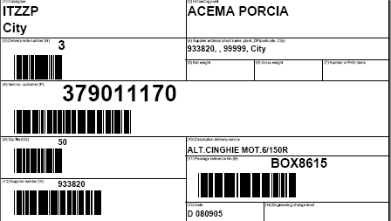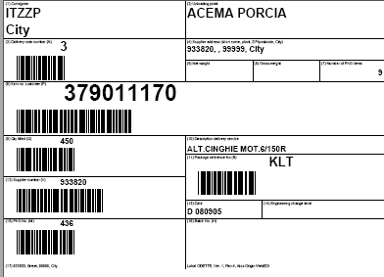
50 pieces
Per box

Code 379011170 ALT.CINGHIE MOT.6/150R
Pallet

Invoice

Creating invoice based on regular delivery
Choose business process Delivery and transport data from the drop box visible on top of the screen. In this section, all previously created shipments can be found.
In table Sent shipments, which is visible on the bottom of the screen, an icon of blank page () is visible in last column. It is provided for all sent shipments, which were not yet used for invoicing.
Important: WebEDI does not allow to create one invoice to several sent shipments.
For example, if you sent two shipments towards a plant (as in below example) it is not possible to create one collective invoice for them, but two separate ones - as the icons of blank sheet appear separately for each of shipments.
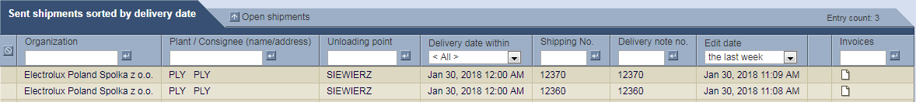
In order to create an invoice, click on the icon of blank page.
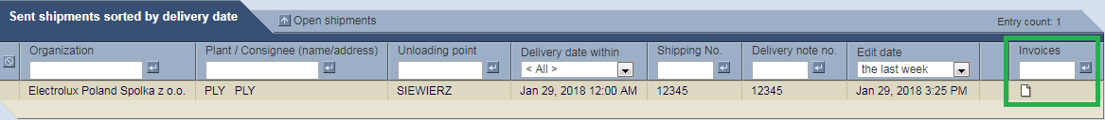
You will be redirected to new section, in which you need to provide some necessary data. Fields marked in orange are mandatory and need to have some data in them.
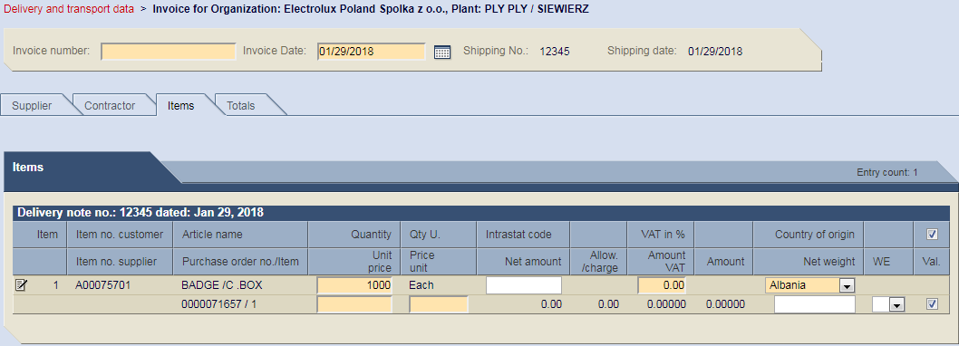

All data that is going to be entered during first creation of an invoice, is going to be remembered and auto-filled in future documents. The only information, which need to be filled each time are the invoice number and date.

Invoice number can be alphanumerical. It is important to provide also proper date of document, which can be chosen by clicking on button .
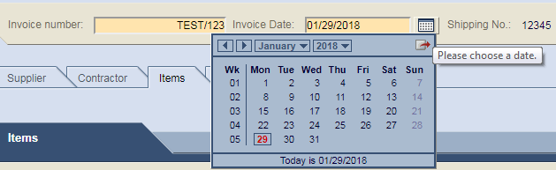
Prices can be entered in Items section. They are going to be remembered by WebEDI for each component and filled automatically in the future.
Important: In case price of a component changes, it has to be changed in WebEDI as well. New price will overwrite the old one in database.

Important:
- Quantity – quantity of articles delivered to client (for example to Electrolux);
- Unit Price – price of article (it is purchasing price for Electrolux);
- Price unit – number of articles which can be bought with Unit Price.

Usually, price unit is 1, so the price is given per one item, but it can be different.

Example 1:
Quantity = 100 PCE
Unit Price = 10 EUR
Price unit = 1 PCE
Net amount = 100 [PCE]*10 [EUR/PCE] = 1.000 EUR

In the above case, one article costs 10 [EUR], so 100 pieces of that article cost 1.000 [EUR].

Example 2:
Quantity = 100 PCE
Unit Price = 10 EUR
Price unit = 10 PCE
Net amount = 100 [PCE]*10/10 [EUR/PCE] = 100 EUR

In the above case, ten article costs 10 [EUR], so 100 pieces of that article cost 100 [EUR].

Please, note that in case the invoice is national and includes VAT charge, it has to be provided in proper field (VAT in %) for each line. System automatically calculates proper VAT amount and Total amount.

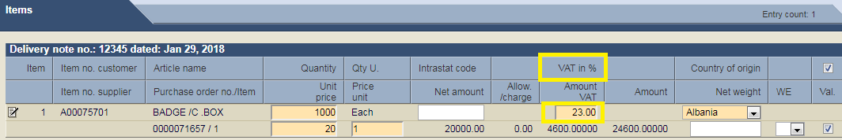

In case the invoice is issued towards Electrolux Italia SPA by the supplier, who is registered in EU, Intrastat code needs to be provided in proper field as well.

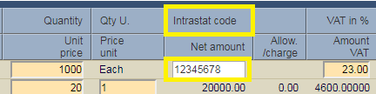
Important: Please, note that at any point you can save your invoice by clicking on the proper icon and leave the invoice creation segment.

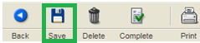

Your open invoice (it is not yet sent) can be found in sections: Delivery and transport data or Invoices. You can enter it again by clicking on icon .

Once section Items is completed, go to Supplier section, in which information about your company can be found. Please, fill it accordingly to below instruction. This step needs to be done during first invoice creation only once per each plant.

Details in Payee section must be the same as in Supplier section. They can be simply copied as it was presented below. VAT ID and Tax number should be filled accordingly to below instruction:
- VAT ID must be numerical (example – 987654321)
- TAX number consists of country code followed by VAT ID (example – PL987654321)

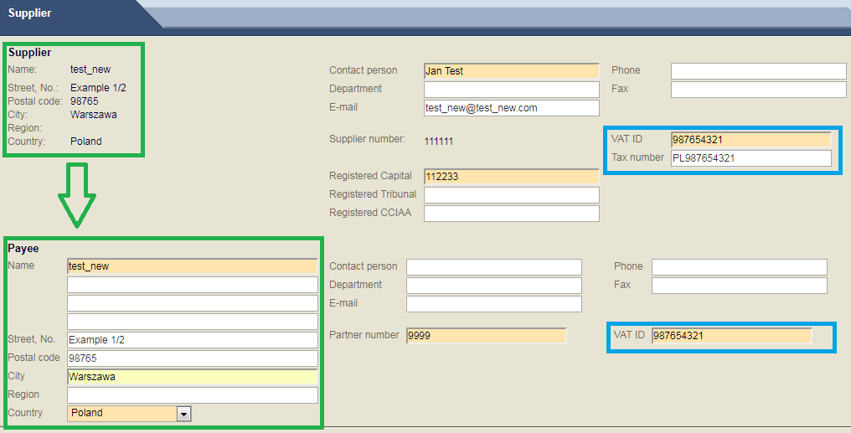

If data provided in Supplier part is not correct (street number, country, city etc. are not valid), please go to Administration, Personal properties and update your Company’s information.
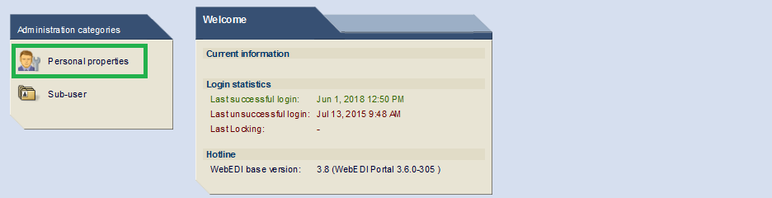

After filling all necessary Supplier data, please go to Contractor section. Here, you need to fill out Invoice recipient address. This has to be done only once per each plant.
Please, fill this part exactly as shown on below example (fields marked in green). The address provided here should be the one of Global Shared Service Centre in Krakow.
When it comes to the Invoice recipient no., it should be the number which is assigned in your system to Electrolux. In case you do not have one, please enter number 1 in this field.

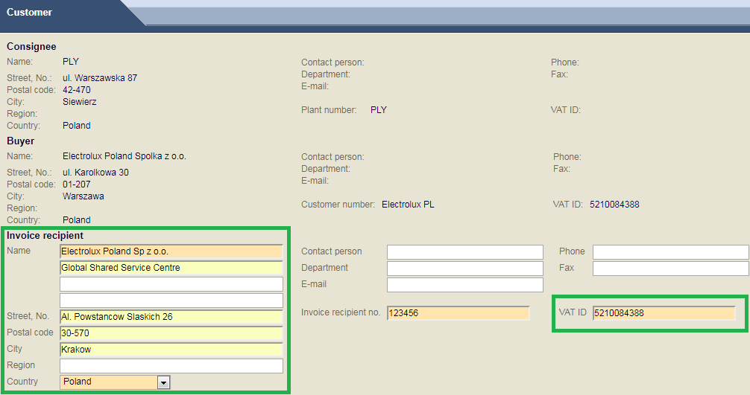

After Contractor data is provided, please go to Totals section. Here, you can choose proper currency, in which your invoice was issued, and enter general information or some legal/regulatory text (if necessary).

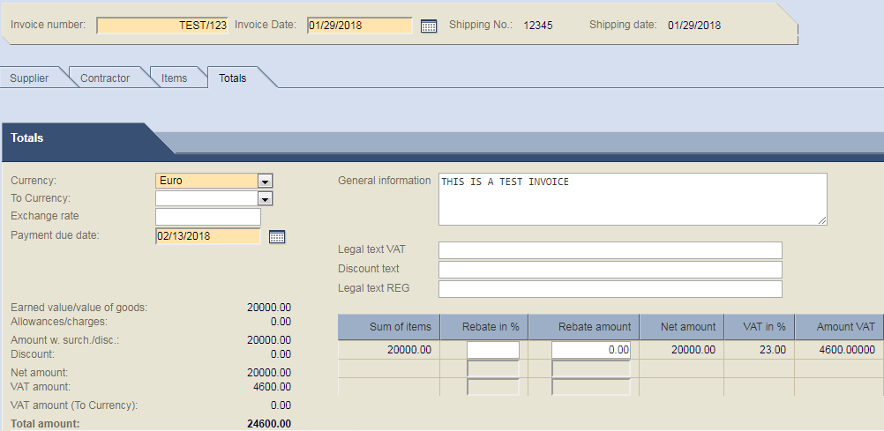

Important: WebEDI offers also option for national invoices in foreign currency. If supplier is registered in Poland and needs to send invoice to Polish factory in currency different then PLN, according to Polish fiscal regulations VAT amount in PLN must be provided on such invoice as well.
In order to add information about VAT in PLN to your invoice, please select proper Currency of your invoice. Then, choose Polish Zloty from the drop list visible next to To Currency field.
The exchange rate is automatically applied. In case it is not correct, please enter it manually.
Important: exchange rate has to be the same as the one on your original invoice

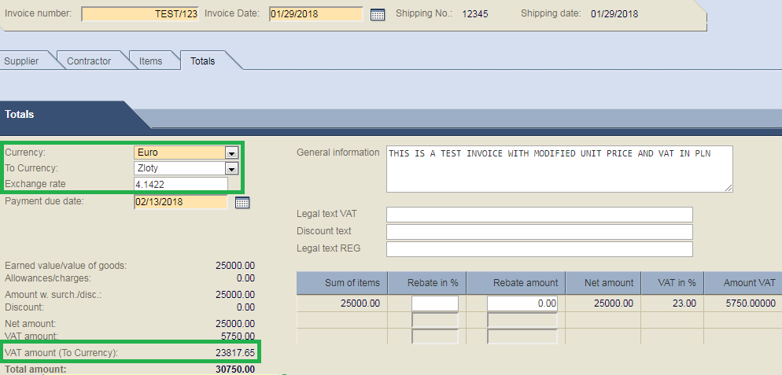

Payment due date field can be ignored, as this information will be overwritten by our internal ERP system.
At this point you should check if Net and Total amounts of the invoice are correct.
In case something is wrong, for example unit price should be changed, you can still go back to the Items section and adjust the data accordingly.

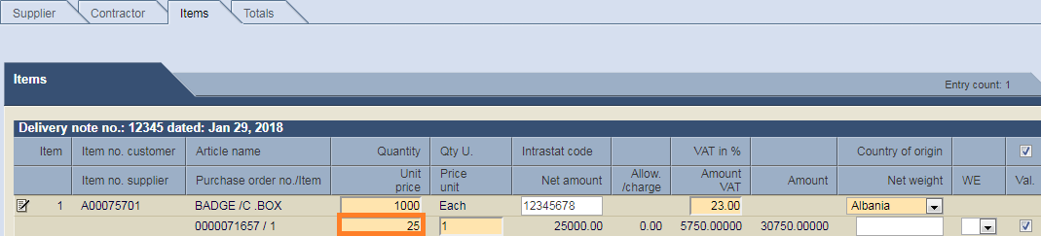

Then, go back to Totals and check if everything matches your original invoice.

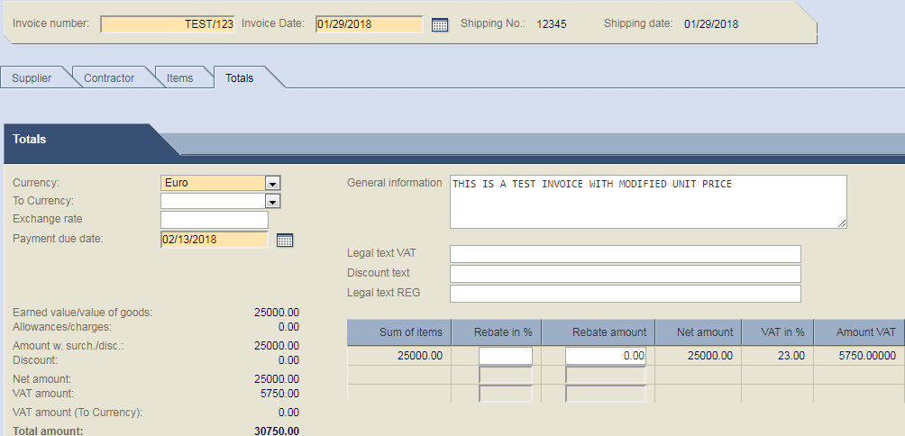

Once all previous steps are completed and you are happy with the result, please save your document and click on the icon Complete, which is visible on the bottom of the screen.

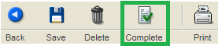

The system will notify you, that your invoice has been saved. Please, note that it was not sent yet.

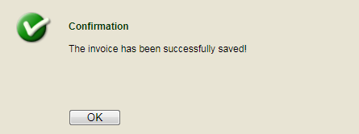

After clicking OK button, you will see a summary section with all previously entered data. Here, you can double check if everything is correct. You can still go back and change something in your invoice, if you notice that something is wrong. In order to do so, please click button Back (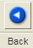).
Do not forget to save your invoice and choose Complete button once you adjust data.
In the summary section, WebEDI provides you with possibility of printing and saving invoice in PDF format. In order to do so, please click on the icon Print visible on the bottom of the screen.

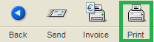

Example of the print out can be seen below.

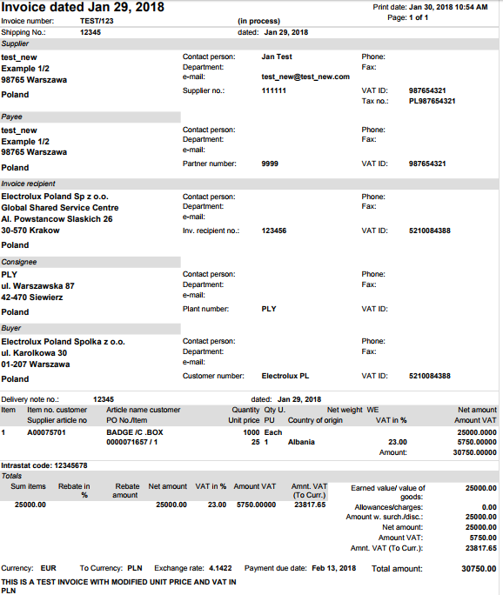

The last step is to send the invoice via WebEDI. It can be done only after clicking Complete button, in the summary section.
In order to provide Electrolux with electronic invoice containing all necessary data provided in previous steps, please choose and click Send icon, which is visible on the bottom of the screen. Only then the document can be received by Electrolux.
Important: It is not possible to change data in invoice, which was sent. Please, make sure all information (prices, addresses, totals etc.) are correct before proceeding.

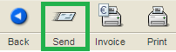

After clicking on above icon, WebEDI should inform you that the invoice has been sent.

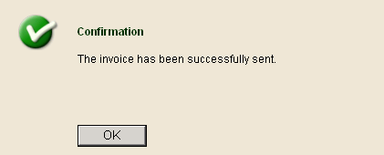

All previously created and sent invoices can be found in section Delivery and transport data (table Sent shipments) or Invoices (table Completed invoices).

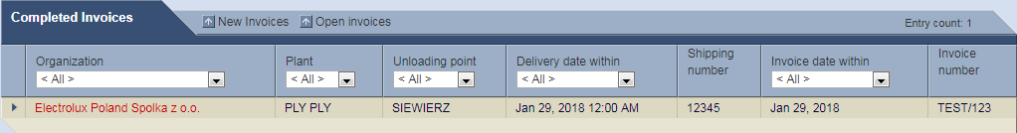

Important: Your company is most probably set in test environment for invoicing at the beginning and documents sent via WebEDI are not used for booking. Please, contact the reference people from Electrolux each time invoice is created, so they can check if it is correct. Once they confirm that your company has been added to production, your WebEDI invoices will be booked automatically.

Invoice based on Toyota Delivery Docket
In order to create an invoice based on Toyota Delivery Docket Number (DDN) it is necessary no send fake (dummy) delivery note, which should contain the same items and corresponding quantities, as provided by T/T.
To create such delivery note, go to section Delivery and transport data. Then choose proper delivery destination and use option Extra delivery from available drop list.

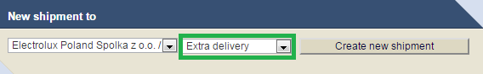

Click on the button Create new shipment. You will be redirected to a new section, in which the Shipping number and Delivery note number will have to be indicated. It is important that both of these numbers are the same as DDN provided by Toyota.
The Shipping number and the Delivery note number should be entered directly in fields marked in red below.

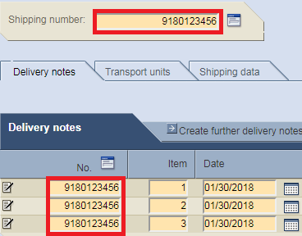

After these steps are completed, please choose the components which are visible in Delivery Docket provided by Toyota. In order to add more lines, please use the option marked in yellow.

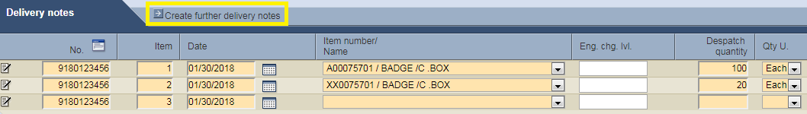

If all lines are added, please go to the Shipping data section. This section can be filled as in below example – the data put here will not be used by our internal ERP system, but WebEDI will not let you complete delivery note unless all orange boxes are filled. Country code should be chosen individually. The name of the supplier that produces the goods can find place in the field 'Plant (supplier)', this information is useful when the link with the manufacturer is Toyota.
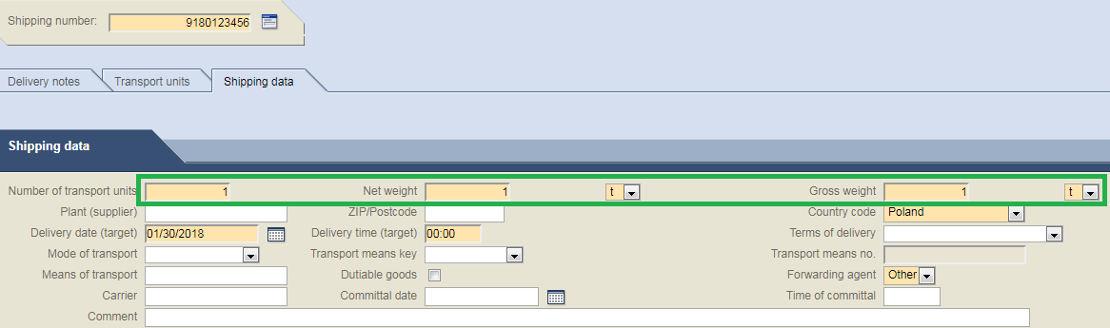

After that step, please click the Complete button visible on the bottom of the page.

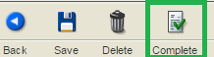

You should be notified by the system that your delivery note was saved.

Important: It is possible that the system will need some additional information, like country of origin of delivered material. In this situation you will have to choose it from the box highlighted in orange and click Complete button once again.

A summary of your delivery note is visible. Please, check if all data is correct. In case there is a mistake (different item was chosen, quantities do not match etc.) it is possible at this point to change the data (button Back, bottom of the screen).
After confirming that everything is correct, please click Send VMI button (this option is valid only in case of using Toyota consignment stock).

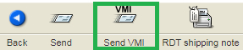

Important: Once the delivery note is sent it is not possible to change or delete it. If you notice that there was a mistake in sent delivery note, please contact with proper factory immediately and ask them to ignore it.
Your delivery note should be visible in Delivery and transport data section in table Sent shipments.

In order to create invoice based on just sent “dummy” shipment, please proceed accordingly to instruction from Subchapter 12.1.

File exchange option
In this short chapter you will become familiar how to use file exchange option that is build into Web EDI application.

Click on highlighted icon (top left part of your screen) in order to open file exchange screens.
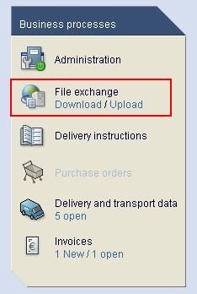

You will find two options available there. Click File upload in order to be able to upload the documents.

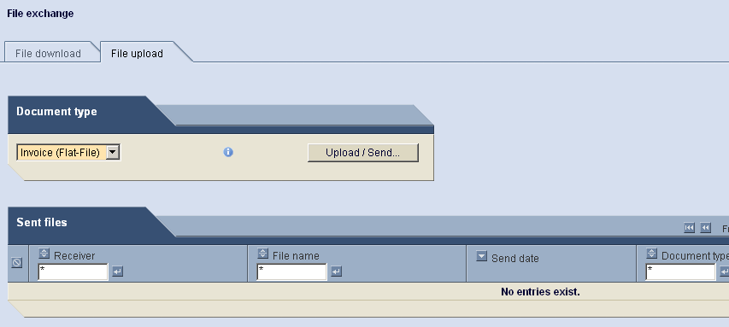

Next you need to select which type of document you would like to upload. There are two options: DespAdv and Invoice.
Once you have selected one of it and clicked “Upload/Send” button you will see the following screen:
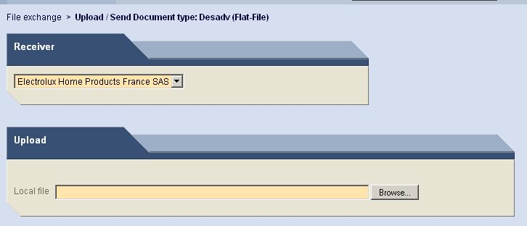
In here you need to select the factory to whom document should be sent to.
Once selection is done, push “browse” to upload correct document.
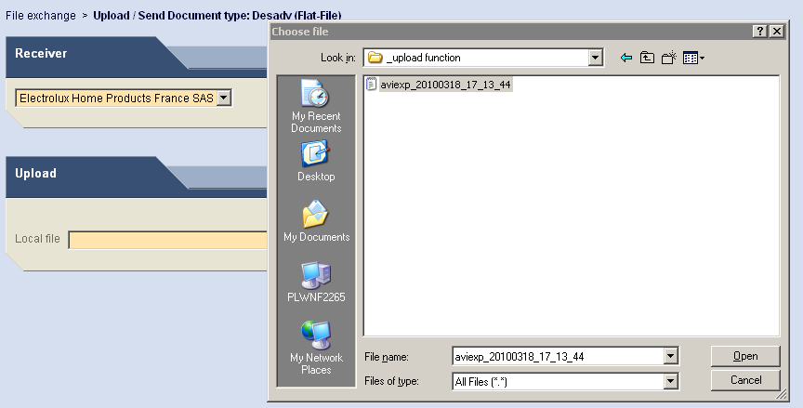

IMPORTANT
As upload function can only work with correct file format, please make sure you are familiar with the format and structure of the file. Detailed file description is attached below.
- for DespAdv

- for Invoice message (Excel file is valid as of 2017-11-30)
.
Once you have successfully attached the file, make sure you push “send” button (located at the bottom of your screen)
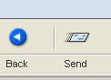

After this you should see the following screen:
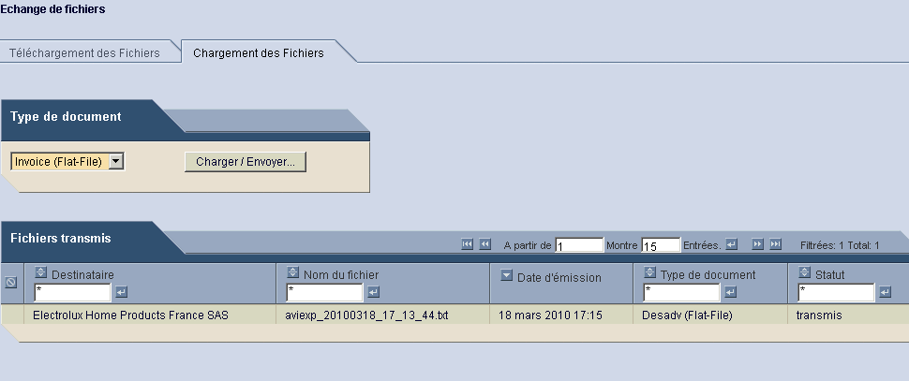

As “file upload option” requires solid IT understanding, we strongly advise you to contact si.support@electrolux.de for validations and additional help if required.

